
WACHEMO UNIVERSITY
COLLEGE OF ENGINEERING AND TECHNOLOGY
DEPARTMENT OF SOFTWARE ENGINEERING
TITLE: ONLINE CAR RENTAL SYSTEM
Group Members ID
1. ABENEZER MERKINE.....................WCU170099
2. NATNAEL ANDUALEM.................. WCU17D8181
3. HABTENESH TILAHUN……...........WCU177395
4. HONELGN TAKELE.........................WCU170611
5. ABDULMAJID TOFIK.......................WCU178190

Submission date :-17/04/2018E.C
Submitted to :- Ms. Senedu and Ms. Fozia
HOSSANA, ETHIOPIA

Acknowledgment
We thank Almighty God for giving us the strength, health, and wisdom to finish our project on the Online Car Rental System. We are grateful to our instructors, Ms. Senedu G. and Ms. Fozia A., for their guidance and support, and to the owner of Kidus Car Rental System for sharing practical requirement that made our work more useful. Finally, we thank our institute and everyone who helped us in any way to complete this project.

Contents
Acknowledgment 1
Chapter one: Introduction 5
1.1 Organization Background 5
1.2 Statement of the Problem 5
1.3 Objectives of the Project 5
1.3.1 General objectives 5
To develop an online system that makes car rental faster, easier, and more accurate for both customers and the organization. 5
1.3.2 Specific Objectives 5
1.4 Methodologies 6
1.4.1 Requirement Elicitation Methodology 6
1.4.2 Requirement Analysis and Modelling 6
1.4.3 System implementation method 7
1.5. Scope and Limitation of the Project 8
1.5.1. Scope 8
1.5.2. Limitation 8
1.6. Significance and Beneficiaries of the project 9
1.7. Feasibility analysis 10
1.7.1. Operational/Organizational Feasibility 10
1.7.2 Technical Feasibility 10
1.7.3 Economic Feasibility 10
1.7.4 Schedule Feasibility 10
1.7.5 Legal Feasibility 10
1.8. Risk Assessment 10
1.9. Development Tools 11
1.10. Work Breakdown 12
1.10.1. Project plan Activities (Schedule) 12
1.10.2 Project Organization 12
1.10.3. Team Organization 12
1.11. Budget plan 13
Chapter Two: Requirement analysis and elicitation 14
2.1 Description of the current system 14
2.2 Player/Actors in the existing system 14
2.3 Use case diagram for existing system 15
2.5 Business rule of existing system 17
2.6 Proposed system 18
2.6.1 Overview 18
2.6.2 Business rules of the new system 18
2.6.3 Functional Requirements 19
2.6.4 Non-Functional requirements 19
2.6.5 Actor & use case identification 20
2.6.6 System model 21
2.6.6.1 Use case Model 21
2.6.6.2. Sequence Diagram 21
2.6.6.2. Sequence Diagram 24
2.6.6.3. Activity Diagram 33
2.6.6.4. State Chart Diagram 38
2.6.6.5. Class Diagram 45
2.6.6.6. User Interface Prototyping 46
Chapter Three: Database Design 48
3.1. Conceptual Database Design of the New System 48
3.1.2. Attributes identification and description 49
3.1.4. ER Diagrams 51
3.2. Logical Database Design of the New System 52
3.2.1. ER to Table Mapping 52
3.2.2. Validate Model using Normalization 53
3.2.2.1. First Normal Form (1NF) 53
3.2.2.2. Second Normal Form (2NF) 53
3.2.2.3. Third Normal form (3NF) 53
3.2.2.4. Other NF 53
3.2.3. Relational Schema with Referential Integrity after normalization 53
3.3. Physical Database Design of the New System 53
3.3.1. Physical Design Strategy 53
3.3.2. Hardware Implementation 53
Chapter Four: System Design 54
4.1. Introduction 54
4.2. Purpose of the System 54
4.3. Design Goals 54
4.4. Current Software Architecture 55
4.5. Proposed Software Architecture 55
4.5.1. Subsystem Decomposition 55
4.5.2. Component Diagram 56
4.5.3. Deployment Diagram 56
4.5.4. Database Diagram 56
4.5.5. Persistent Data Management 57
4.5.6. Access Control and Security 57
4.5.7. Global Software Control 58
4.5.8. Boundary Conditions 58
4.6. Refined ER Diagram 58
Chapter Five: Implementation and Testing 59
5.1. Test Procedure 59
5.2. User Manual Preparation 59
5.3. Training and Installation 59
5.4. Startup Strategy 59
Chapter Six: Conclusion and Recommendation 61
6.1. Conclusion 61
6.2. Recommendation 61
6.3. Reference 61
6.4. Appendix 61

Chapter one: Introduction

1.1 Organization Background
Kidus Car Rent is a car rental organization in Ethiopia, located in Hossana. The company provides cars for different purposes, such as personal use, institutional use, and various events. Its main office is also found in Hossana. Kidus Car Rent is preparing to officially launch in 2018 E.C.
The organization currently has more than 20 employees, and most of their daily activities are done using a manual system. This makes their work slower and sometimes less accurate. As the company continues to grow, it needs a better system that can make its services faster and more efficient.

1.2 Statement of the Problem
Many car rental companies still use paper and manual work like handwritten contracts and face-to-face bookings. This old way of working causes problems such as slow reservations, double bookings, poor customer service, and difficulty in tracking which cars are available. Manual systems also lead to mistakes, lost records, and trouble handling payments.
Today, customers want fast, easy, and reliable service. Other companies with online systems already give quick booking, secure payments, and real-time car availability, which makes paper-based companies fall behind. Without automation, it is hard to meet customer needs, keep accurate records, and make good business decisions.
So, there is a clear need for an Online Car Rental System that handles booking, payments, car management, and reports automatically. This will make work faster, reduce errors, improve customer satisfaction, and give managers correct information for better decisions. Moving from paper to digital will help car rental companies stay competitive and grow.

1.3 Objectives of the Project

1.3.1 General objectives
To develop an online system that makes car rental faster, easier, and more accurate for both customers and the organization.

1.3.2 Specific Objectives
- To gather and document general functional and non-functional requirements from all key stakeholders.
- To Design online platform for the car rental system.
- To make car renting easier by allowing customers to book cars online without visiting the office.
- To show which cars are available in real time so users can quickly find a car that fits their needs.
- To keep customer information safe and secure using login and basic security features.
- To help admins manage cars easily by adding new cars, updating info, or removing unavailable cars.
- To automate payments and receipts so customers can pay online and get instant confirmation.
- To store and track all rental histories for both customers and admins to view anytime.
- To reduce paperwork and human errors by shifting everything from manual records to digital records.
- To provide an easy way to compare cars based on price, model, and rental rate.
- To generate useful reports such as daily bookings, income reports, and car usage for better business decisions.
- To make the system usable on phones so customers can rent cars anytime from anywhere.

1.4 Methodologies

1.4.1 Requirement Elicitation Methodology
- Interviews
- We sat down with managers and discussed about the system.
- We asked them about their daily work, problems, and what they expect from the new system.
- We listened carefully and wrote down their needs in simple words.
- Surveys
- We made short surveys and sent them to many people.
- They told us what they like, what they don’t like, and what features they want.
- Observation
- We will watch how car rental staff handle reservation, payments, and customer service.
- We noticed where things are slow or confusing.
- We also looked at similar projects from other companies.
- This helped us learn new ideas and make changes to improve our own system.
- Prototyping
- We will draw simple screens (wireframes/mockups) of how the system might look.
- We showed these to staff and customers.
- They gave us feedback, and we improved the designs step by step.

1.4.2 Requirement Analysis and Modelling
Requirement Analysis
- Identify the Stakeholders
- Stakeholders are people who use or benefit from the system
- Customers – Book and rent cars online
- Admin – Manages cars, customers, and bookings
- Staff – Handles car pickup, return, and inspection
- Management – Views reports for decision-making
- Gather Information
- Interviews
We interviewed the owner of kidus car rent and get the general objectives and other requirements also we can get to the system and existing business rule of the organization.
- Surveys
We try to see other webs online and get general understanding about the system.
-Observing the current system
- Finding problems such as paperwork delays, car availability issues, and manual errors
-Define the Requirements
- Identified Functional Requirements (System Features) and Non-Functional Requirements (System Quality)
-Identify Use Cases
- use case shows how different users interact with the system.
Modeling Techniques
- Use Case Diagram
- Activity Diagrams
- Sequence Diagrams
- Class Diagrams
- ER Diagram for Database part

1.4.3 System implementation method
We preferred to use the Prototyping Model because it allows us to develop the system step by step. In this approach, an early version of the system (a prototype) is first created to show how the main features will work. This prototype is then reviewed by users, and their feedback is used to improve and refine the system.
By following the prototyping model, we gain flexibility during development and can easily make changes whenever users suggest improvements. This helps us better understand their real needs and expectations. As a result, the final Online Car Rental System becomes more accurate, user-friendly, and effective in supporting the overall car rental management process.

1.5. Scope and Limitation of the Project

1.5.1. Scope
This system is designed to modernize the slow and inefficient manual car rental process with a modern, fast, and user-friendly online platform. It aims to simplify the entire workflow from searching for a car to booking, payment, and report generation while improving accuracy and reducing workload for staff. The system will allow customers to create their own accounts, log in, update their details, and view their rental history. Administrators will also have access to manage user accounts and monitor customer activity. Admins will be able to add new cars, update information such as model, type, price, and availability, and remove cars when needed. The system will also show customers a clear list of available vehicles with images, descriptions, and prices so they can easily choose the car that suits their needs.

1.5.2. Limitation
- Internet and Technology dependence-Requires stable internet access which is difficult for users in remote areas.
- Security and Privacy Risk -Customers data can be vulnerable if the system is not well protected.
- Lack of personal interaction -Some users may prefer face-to-face help.
- Device compatibility issues- Every devices may not be compatible due to difference of versions and other related specifications.
- Payment-Related issues-Online payment may fail, delay or technical errors may interrupt booking.

1.6. Significance and Beneficiaries of the project
- Significance
-Changes the old manual process into a fast and modern digital system.
-Reduces mistakes and improves accuracy in daily work.
-Makes car rental available anytime and anywhere for customers.
-Speeds up services like booking, returning, and payment processing.
-Automates tasks such as booking, payment tracking, and record keeping.
-Helps the company work more smoothly and professionally.
-Improves customer experience and satisfaction.
-Saves time, reduces workload, and increases productivity.
-Supports the company’s growth as the system can expand easily.
- Beneficiaries
Customers
- Ability to book a car online anytime, Quick access to car availability and prices, Reduced need to visit the office physically, Faster service and improved convenience.
Organization
- Reduced paperwork and human errors, Better tracking of cars, rentals, and payments, Faster service delivery, Organized digital records for all customers and transactions.
Managers/Administrator
- Access to automated statistical reports, Better decision-making supported by data.
Developers team
- Practical experience in system analysis, design, and development, Exposure to real-world requirements gathering.

1.7. Feasibility analysis

1.7.1. Operational/Organizational Feasibility
The system replaces slow manual processes with a faster, automated workflow that improves booking, payment, and car management. Staff and customers can use it easily with minimal training, making it operationally practical.

1.7.2 Technical Feasibility
The project uses simple, available technologies such as HTML, CSS, PHP, and MySQL, which the team already understands. All required tools and hardware are accessible, making technical implementation achievable.

1.7.3 Economic Feasibility
Most software tools are free, and the total project cost is manageable for the team. The system will reduce long-term expenses such as paperwork and errors, making it financially beneficial.

1.7.4 Schedule Feasibility
The tasks are clearly divided and fit within the planned 19–29 week timeline. Using the prototyping model allows faster development and easy adjustments when needed.

1.7.5 Legal Feasibility
The system follows rules of the country.
Art. 2082.- 2. Keeper or agent.
A person who has taken possession of the machine or vehicle for purposes of personal gain shall be liable for any damage caused by the machine or vehicle while in his possession.
This article shows that the rule of country and the person that broke the law is asked based on this law.

1.8. Risk Assessment
Table 1.1: Risk Assessment
Risks | Mitigations
Difficulty in implementing features– Some parts of the system, like booking, payment, or vehicle management, are complex and could slow development. | Divide the work into smaller, manageable tasks. Focus on one feature at a time and seek help from instructors or online tutorials when needed.
Privacy issues with customer data – Storing and using customer information may raise privacy concerns. | Use anonymized or test data for development and follow basic data protection practices to keep information secure.
Changes in project requirements – Adding extra features or changing requirements during development may cause delays or confusion. | Set clear goals and requirements at the beginning. Only make changes after careful discussion and approval.
Limited access to technical resources – Lack of software, hardware, or technical skills can affect progress. | Use university labs, free software tools, and seek guidance from instructors or peers.
Team coordination challenges – Miscommunication or unclear responsibilities can disrupt workflow. | Hold regular team meetings, define roles clearly, and track progress using collaborative tools.

1.9. Development Tools
Software part
- Google Chrome / Mozilla Firefox – To test and check website functionality and performance.
- MySQL for Data base
- Ms Word Office for write documentation
- Enterprise Architecture for UML.
- Visual studio code for code editor
- HTML/CSS/JavaScript for frontend development
- PHP for backend development
Hardware part
- 32 GB USB Flash Disk for backup
- A4 paper for Hard copies of document
- PC 512SSD for development purpose

1.10. Work Breakdown

1.10.1. Project plan Activities (Schedule)
Table 1.2 schedule
Activities | Time | Phase
Requirement gathering and analysis | 2-3 weeks | Initial Phase  Initialization and Plan
System Design | 5-8 weeks
Development | 7-10weeks
Testing | 2-3 weeks
Deployment | 3-5 weeks | Final Phase Deployment
Total time | 19-29 weeks

1.10.2 Project Organization
Project Manager: Oversees the entire project, ensures deadlines are met, and communicates with supervisors.
System Designer: Plans the system structure, database, and user interface.
Developer: Implements the code, both front-end and back-end.
Tester: Tests the system for errors and ensures it meets requirements.

1.10.3. Team Organization
Table 1.3 Team Organization
Co-workers | Role
Abenezer Merkine | Project Manager
Abdulmajid Tofik | Requirement gathering, analysis, and Documentation
Habtenesh Tilahun | System Designer
Natinael Andualem | Implementation and code
Honelign Takele | Testing

1.11. Budget plan
Table 1.4 Budget Plan
Item | Quantity | Cost
Pc | 1 | 70,000 birr
Professional income | - | 150,000 birr
Flash Disk | 1 | 1000birr
Print | - | 4000 birr
Software and Hardware cost | - | 10,000 birr
Backup | - | 200,000 birr
Total cost | - | 435,000 birr

Chapter Two: Requirement Analysis and Elicitation

2.1 Description of the current system
The current car rental operation is fully manual & paper based. When customers want to rent a car, they must visit the company physically & provide their personal info to the employee. The employee records customer details, car info & rental agreements on paper forms.
To check car availability, the employee must manually search through files or physically check the parking area. Rental payments are calculated using a calculator and recorded in notebooks.
When the car returned, the return date and condition are written manually in paper sheet.

2.2 Player/Actors in the existing system
Customer
- Requests a car for rental & provides personal information such as Email, phone number & driving license.
Employee
- Works on managing reports and managing cars.
Manager
- Leader of organization and Supervises operations, view feedbacks, approves rental decisions and other useful decisions.
Admin
- Manages the users account, check payment

2.3 Use case diagram for existing system
Figure 2.1 use case for existing system
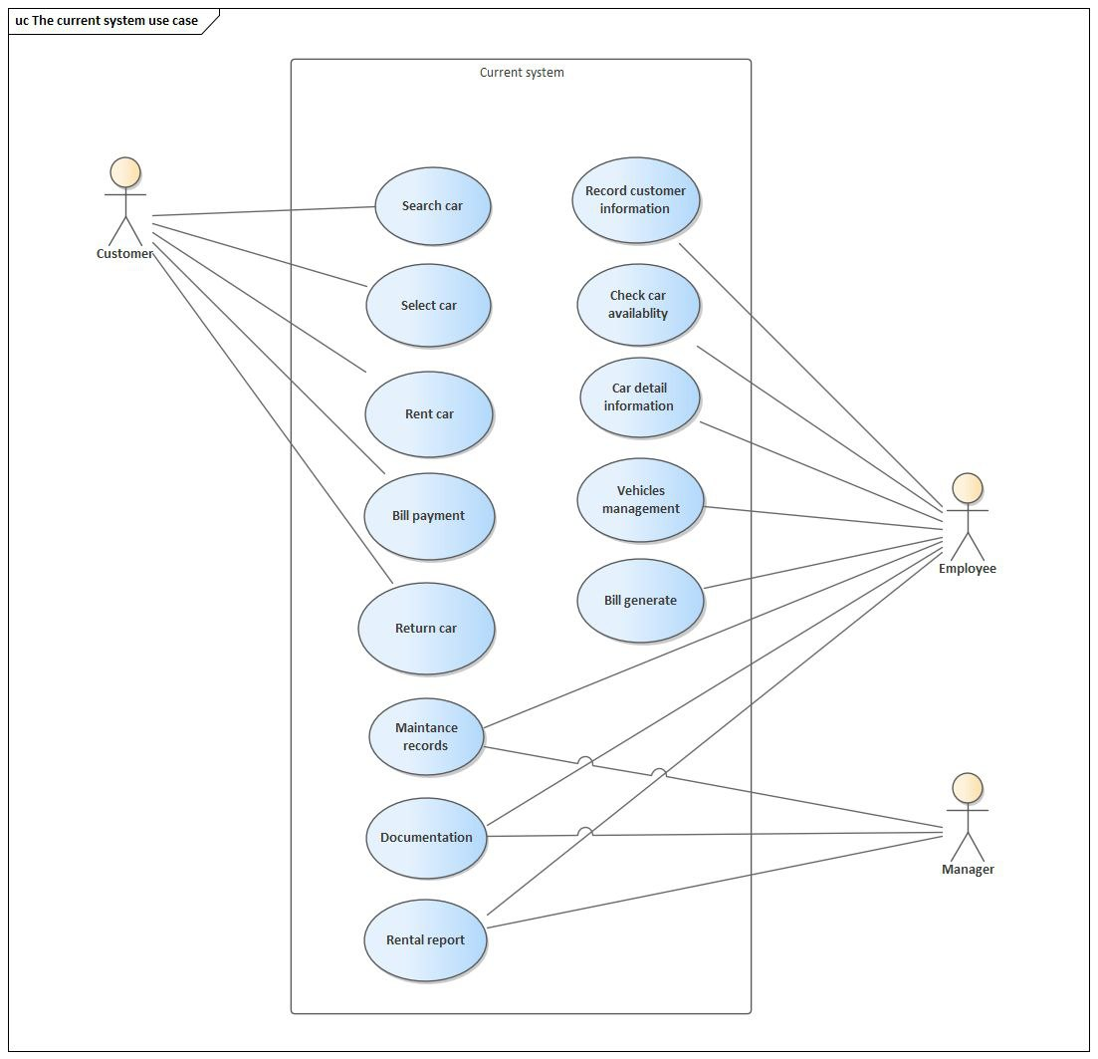

2.4 Forms & documents used in the existing system
Figure 2.2 Forms & documents used in the existing system

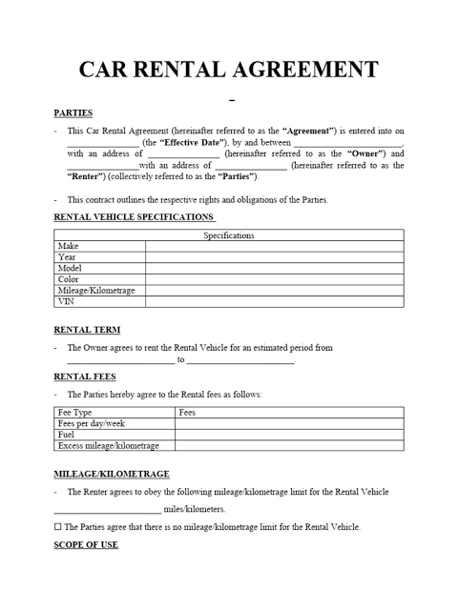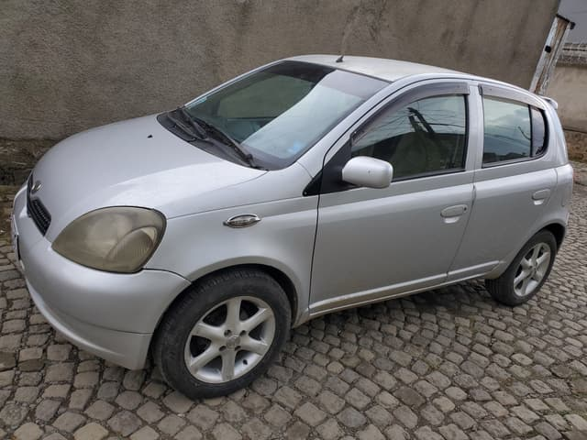


2.5 Business rule of existing system
- The customer must provide a valid driving license to rent a car.
- Customers must be at least 21 years old to rent a vehicle
- A car can be rented only if it is available.
- Customer information must be recorded and placed securely before renting a car.
- The rental agreement form must be completed before releasing the car.
- Late returns incur a fee based on the daily rental rate.
- Any reported issues must be addressed on time and the customer takes the whole responsibility.
- The person who broke the contract is pays 20,000 to the other.
- Payment must be processed before the vehicle is handed over to the customer.
- Fuel service charges apply if the vehicle is not returned with the required fuel level.
- Vehicles must be returned with the same level of fuel as at the time of rental.
- The manager reviews daily rental records to monitor the business.

2.6 Proposed system

2.6.1 Overview
The proposed car rental management system is a computerized a solution designed to replace the existing manual process used by the organization. The system automates all major activities such as customer registration, car registration, checking car availability, renting cars, returning cars & recording payments.
Using the system, employees can easily search for available cars, manage customer information & record rental transactions in a fast & easy. The system will also generate reports that help the manager work actively and all activities more effectively.
This system also give another function for customers that they can reserve the car without limited by place also can give feedback to the organization.

2.6.2 Business rules of the new system
- Customers must register, have to provide and verify all essential information to their account before making reservations.
- Customers must be at least 21 years old to rent a vehicle
- The customer must provide a valid driving license to rent a car.
- Only authenticated users can access reservation and payment services.
- Problem issue is happened it should announced on the time of problem.
- A customer cannot reserve more than one car at the same time.
- Payment must be completed before the car is handed over.
- Cars must be returned on the agreed return date.
- Penalty fees apply for late return & car damage.
- The system records car condition and fuel level at pickup and return.

2.6.3 Functional Requirements
User management
- On this phase allow new user to registered and create account with valid personal information, also allow login to users if the account is existed before.
- Allow users to view & update their personal information.

Car Management
- Enable customer to view available cars with details like model, price & features.
- Employee can able to add, update, remove car information.

Booking and Reservation

- Customers can search, reserve confirm or cancels their booking and reservation.

Payment Process

- Secure transaction Integrate with different payment methods, then it will be verified then online bill will generated.

2.6.4 Non-Functional requirements

Security

- Protect user data and payment information and transactions.

Performance

- Create fastest system to response (example: 2 second for simplest task & 20 seconds for complex task).

Availability

- The system is available in a situation that internet connection is available.

Reliability

- Minimize errors, provide clear and helpful messages when error is occurred, and check valid transactions.

Usability

- The interface must be simple, easy and clear to use.

Scalability

- The system must support future growth (more cars, customers).

Maintainability

- System error should be easy to detect & fix.

2.6.5 Actor & use case identification
Actors

- Customer
- Employee
- Manager
- Admin

Use case identification

- Customer

- Login
- Register
- Update Profile
- Browse car
- Reservation
- Make payment
- View Rental History
- Send Feedback
- Logout
- Employee
- Login
- Manage Report
- Manage car
- Add Car information
- Remove Car information
- Update Car information
- Logout
- Manager
- Login
- Mange Reservation
- Reject Reservation
- Approve reservation
- View Feedback
- View report
- Logout
- Admin
- Login
- Manage user account
- Check Payment
- Manage Reservation
- Reject reservation
- Approve Reservation
- Logout

2.6.6 System model

2.6.6.1 Use case Model
Figure 2.3 Use case For Proposed System
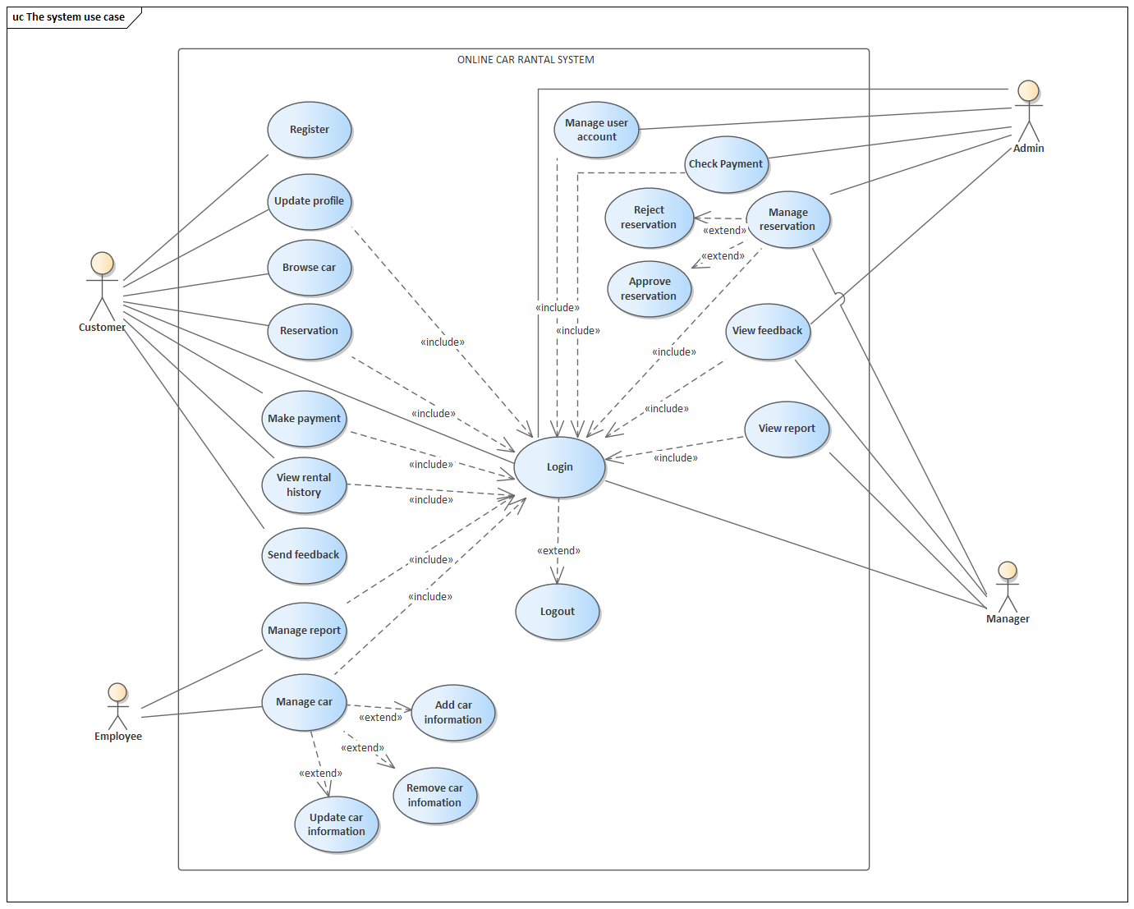
Table 2.1 Use case Description
Use case | description
Register  Actor: Customer | Description: Allows a new customer to create an account in the system.  Pre-condition: Customer does not already have an account.  Main Flow:  Customer enters personal details.  System validates the information.  System creates a new account.  Post-condition: Customer account is created successfully.
Login  Actor: Customer, Employee, Admin, Manager | Description: Authenticates users to access the system.  Pre-condition: User must be registered.  Main Flow:  User enters username and password.  System verifies credentials.  User is redirected to their dashboard.  Post-condition: User is logged in.
Logout  Actor: Customer, Employee, Admin, Manager | Description: Ends the user’s active session.  Pre-condition: User must be logged in.  Main Flow:  User selects logout.  System terminates the session.  Post-condition: User is logged out.
Update Profile  Actor: Customer | Description: Allows customers to modify their personal information.  Pre-condition: Customer must be logged in.  Main Flow:  Customer views profile.  Customer updates information.  System saves changes.  Post-condition: Profile is updated.
Browse Car  Actor: Customer | Description: Enables customers to view available cars.  Pre-condition: None  Main Flow:  Customer views car list.  System displays car details.  Post-condition: Available cars and car details are shown.
Reservation  Actor: Customer | Description: Allows customers to reserve a selected car.  Pre-condition: Customer must be logged in.  Main Flow:  Customer selects a car.  Customer enters reservation dates.  System records reservation.  Post-condition: Reservation request is created.
Make Payment  Actor: Customer | Description: Enables customers to pay for a reservation.  Pre-condition: Reservation must exist.  Main Flow:  Customer selects payment method.  System processes payment.  Payment status is updated.  Post-condition: Payment is completed.
View Rental History  Actor: Customer | Description: Allows customers to view previous rentals.  Pre-condition: Customer must be logged in.  Main Flow:  Customer requests rental history.  System displays past rentals.  Post-condition: Rental history is shown.
Send Feedback  Actor: Customer | Description: Enables customers to send feedback about services.  Pre-condition: Customer must be logged in.  Main Flow:  Customer writes feedback.  System stores feedback.  Post-condition: Feedback is saved.
Manage User Account  Actor: Admin | Description: Allows admin to manage system user accounts.  Pre-condition: Admin must be logged in.  Main Flow:  Admin views user list.  Admin creates, updates, or deactivates accounts.  Post-condition: User accounts are managed.
Check Payment  Actor: Admin | Description: Allows admin to verify customer payments.  Pre-condition: Payment must exist.  Main Flow:  Admin views payment details.  System displays payment status.  Post-condition: Payment is verified.
Manage Reservation  Actor: Admin | Description: Enables admin to manage customer reservations.  Pre-condition: Reservation must exist.  Main Flow:  Admin reviews reservation.  Admin approves or rejects reservation.  Post-condition: Reservation status is updated.
Approve Reservation  Actor: Admin | Description: Confirms a customer’s reservation request.  Pre-condition: Reservation must be pending.  Main Flow:  Admin approves reservation.  System updates status.  Post-condition: Reservation is approved.
Reject Reservation  Actor: Admin | Description: Declines a reservation request.  Pre-condition: Reservation must be pending.  Main Flow:  Admin rejects reservation.  System updates status.  Post-condition: Reservation is rejected.
View Feedback  Actor: Admin, Manager | Description: Allows viewing customer feedback.  Pre-condition: Feedback must exist.  Main Flow:  User requests feedback.  System displays feedback.  Post-condition: Feedback is viewed.
View Report  Actor: Manager | Description: Allows manager to view system reports.  Pre-condition: Manager must be logged in.  Main Flow:  Manager selects report.  System generates report.  Post-condition: Report is displayed.
Manage Report  Actor: Employee | Description: Enables employees to manage report data.  Pre-condition: Employee must be logged in.  Main Flow:  Employee creates or updates report.  System saves changes.  Post-condition: Reports are managed.
Manage Car  Actor: Employee | Description: Allows employees to manage car information.  Pre-condition: Employee must be logged in.  Main Flow:  Employee selects car management.  Employee adds, updates, or removes car data.  Post-condition: Car data is updated.
Add Car Information  Actor: Employee | Description: Adds new car details to the system.  Pre-condition: Employee must be logged in.  Main Flow:  Employee enters car details.  System saves the information.  Post-condition: New car is added.
Update Car Information  Actor: Employee | Description: Updates existing car details.  Pre-condition: Car must exist.  Main Flow:  Employee edits car details.  System updates information.  Post-condition: Car information is updated.
Remove Car Information  Actor: Employee | Description: Removes car data from the system.  Pre-condition: Car must exist.  Main Flow:  Employee selects car.  System deletes car record.  Post-condition: Car is removed.

2.6.6.2. Sequence Diagram
Figure 2.4 Sequence Diagram for View Report

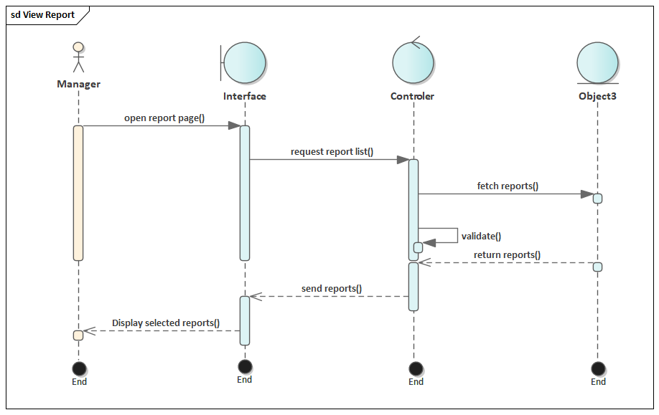
Figure 2.5 Sequence Diagram for view feedback
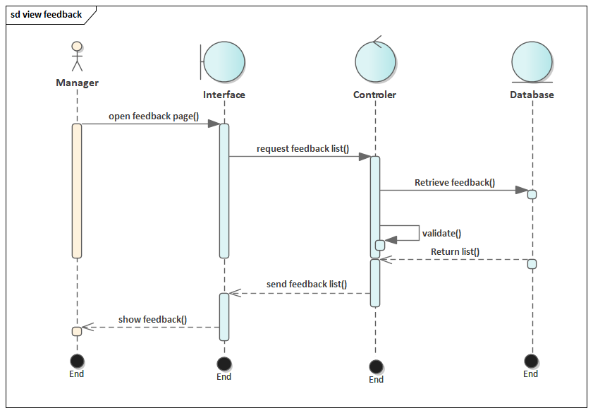
Figure 2.6 Sequence Diagram for update profile
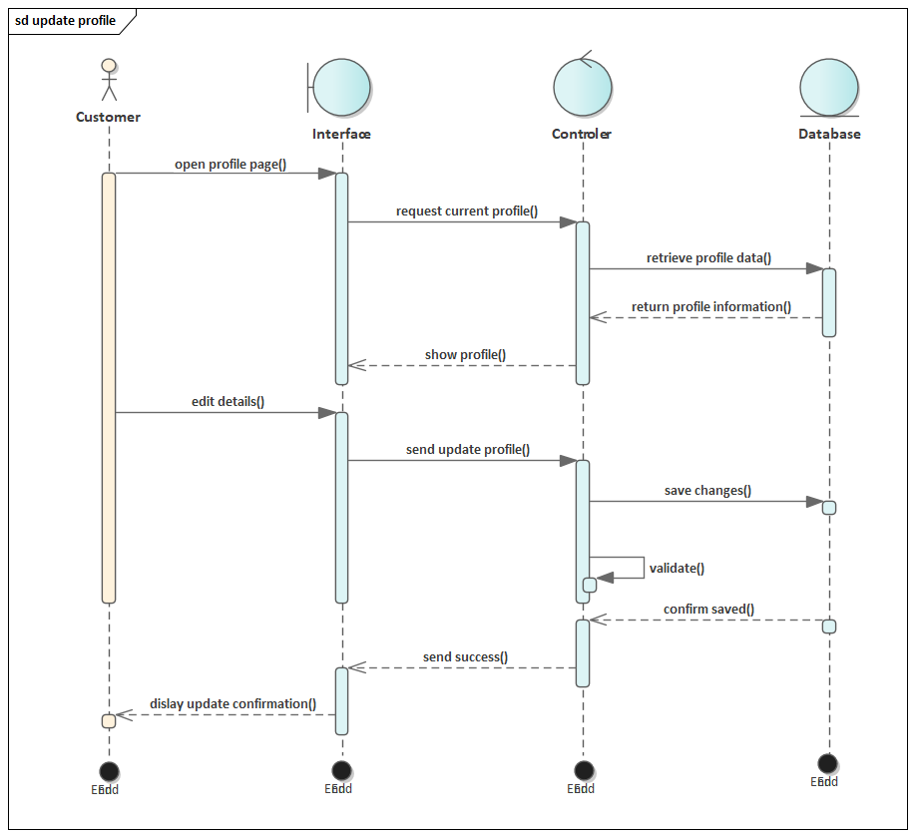
Figure 2.7 Sequence Diagram for send feedback
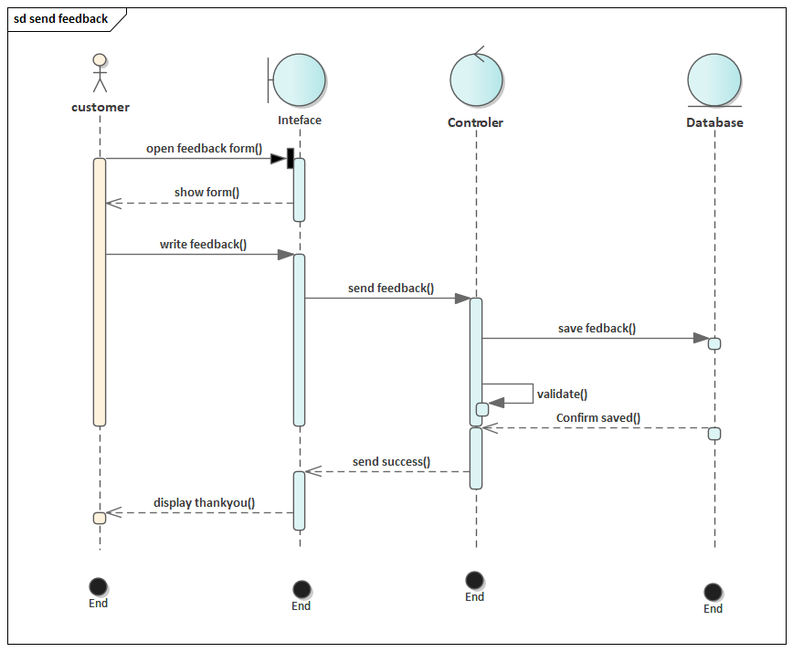
Figure 2.8 Sequence Diagram for Reservation
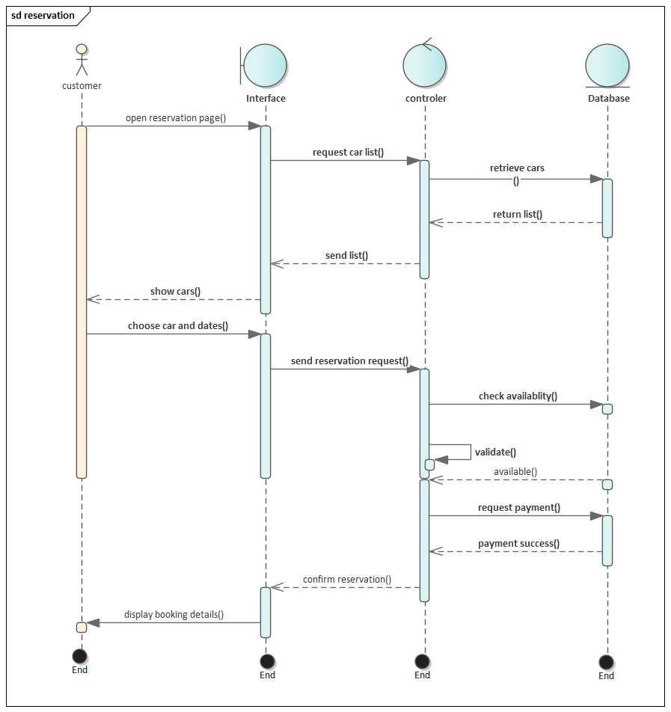
Figure 2.9 Sequence Diagram for Register
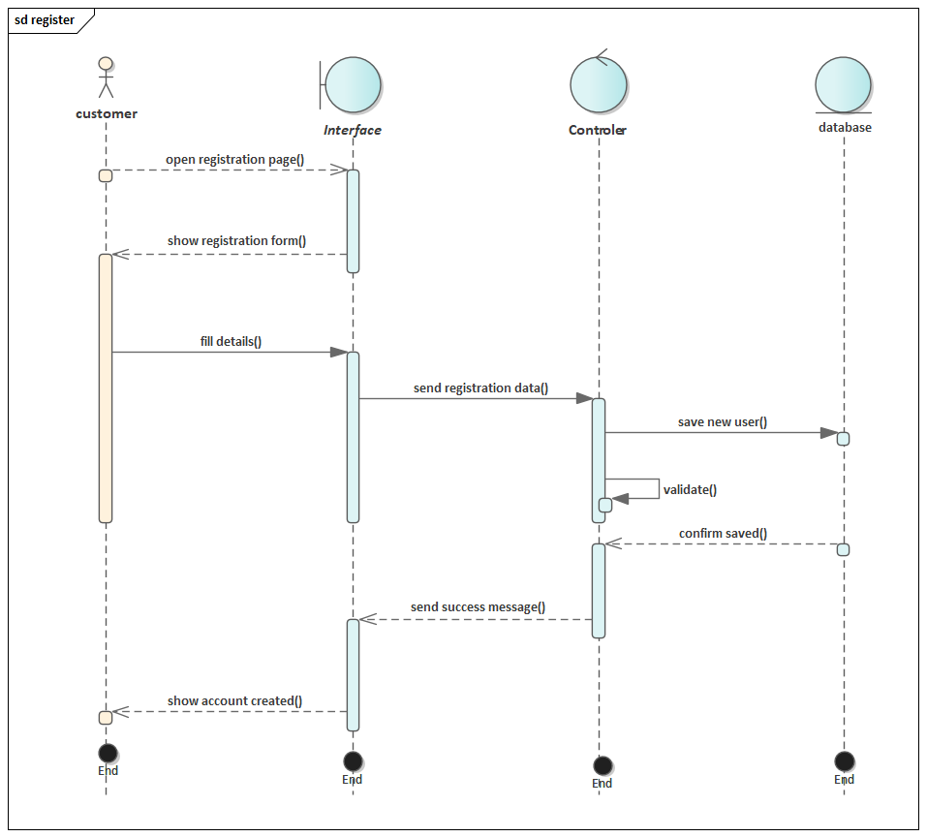
Figure 2.10 Sequence Diagram for manage users account
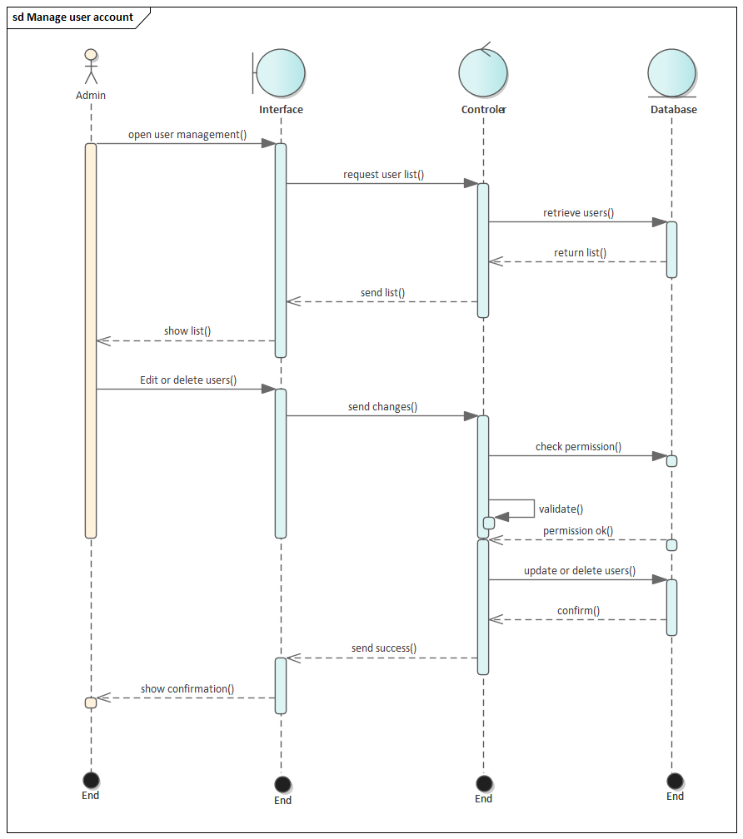
Figure 2.11 Sequence Diagram for manage report
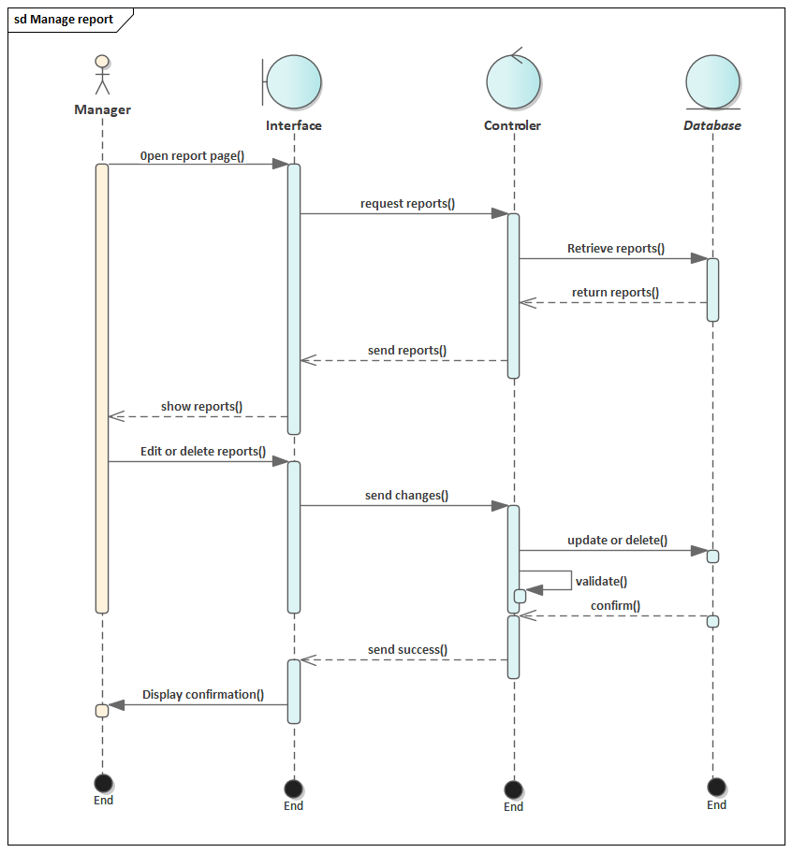
Figure 2.12 Sequence Diagram for login
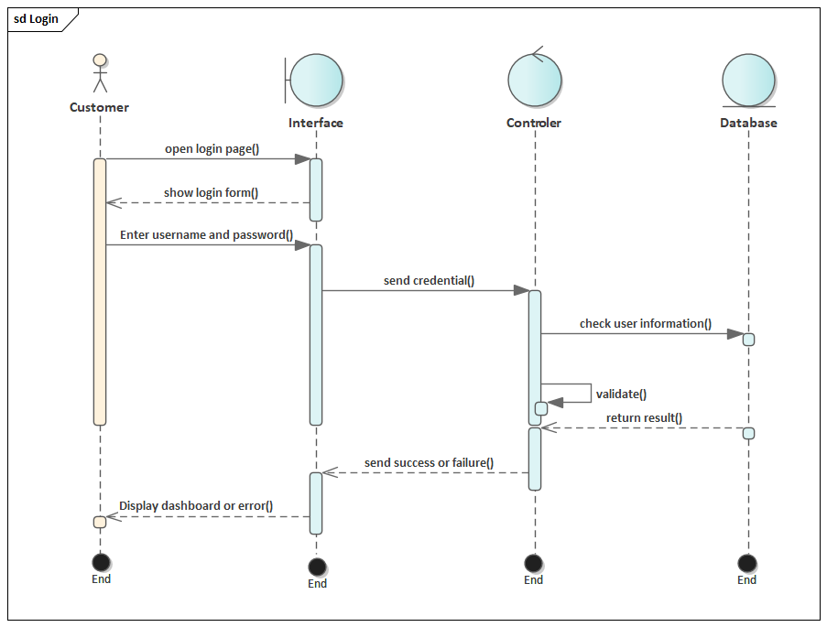
Figure 2.13 Sequence Diagram for browse car
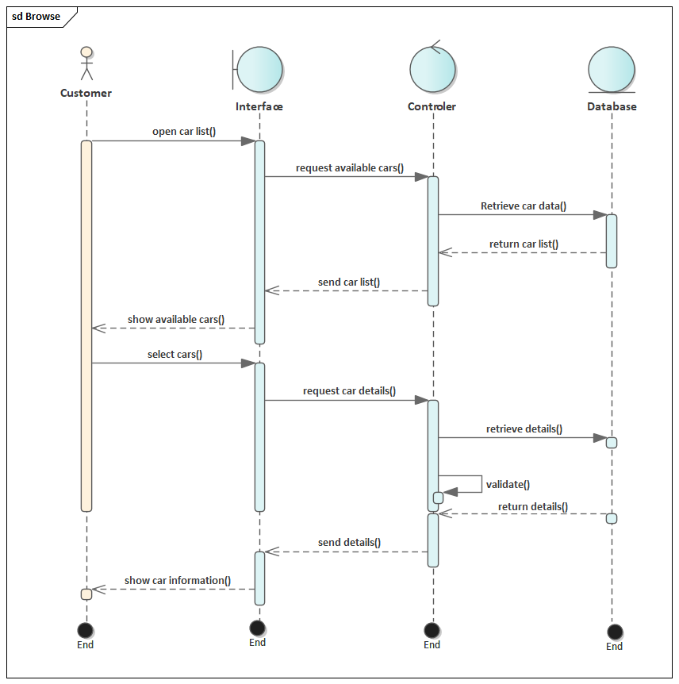

2.6.6.3. Activity Diagram
Figure 2.14 Activity Diagram browse car

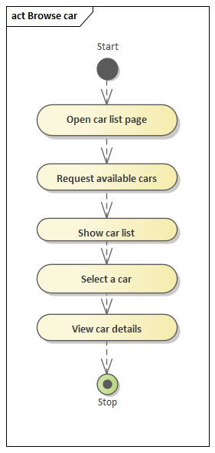
Figure 2.15 Activity Diagram Login
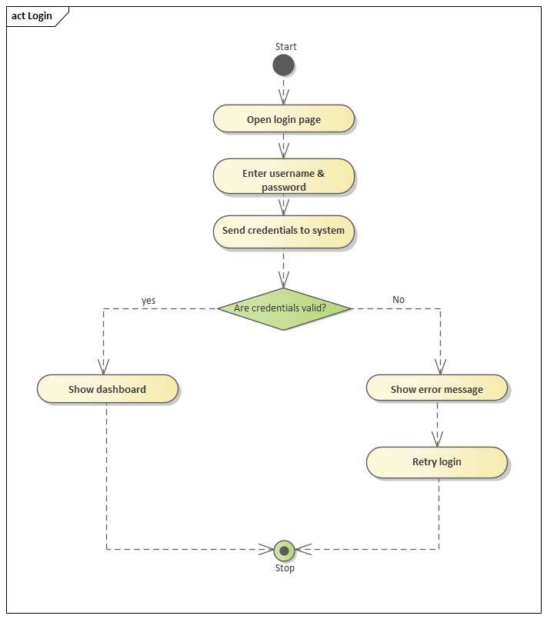
Figure 2.16 Activity Diagram manage user account
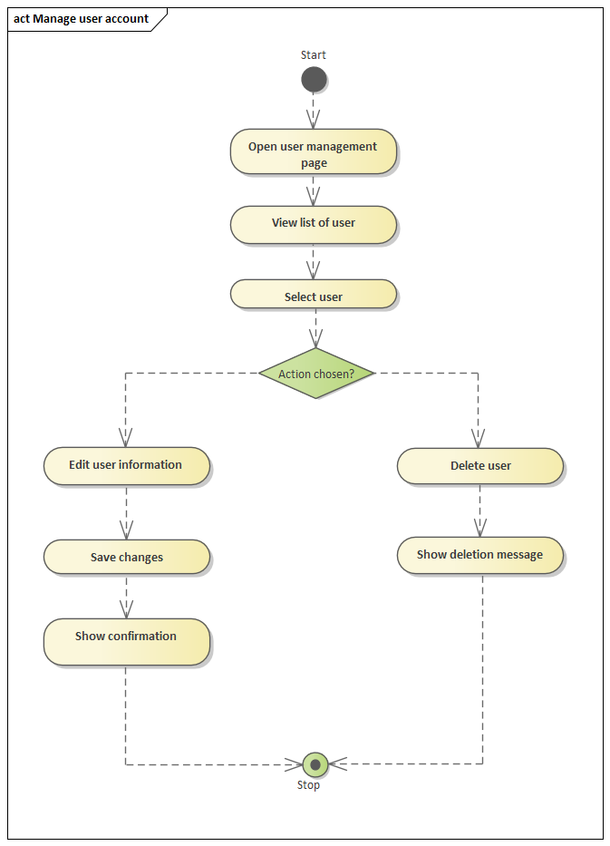
Figure 2.17 Activity Diagram manage Report
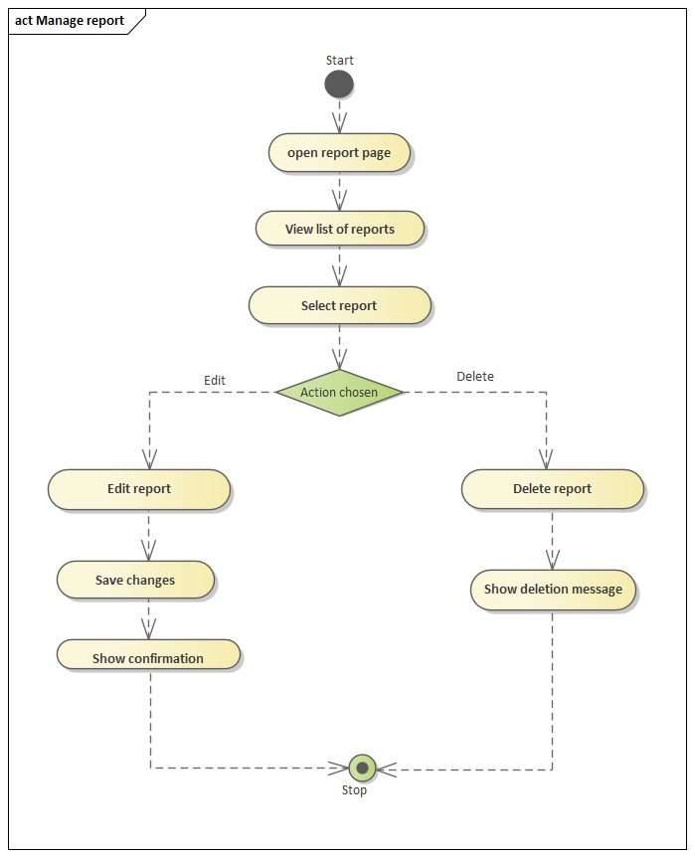
Figure 2.18 Activity Diagram register

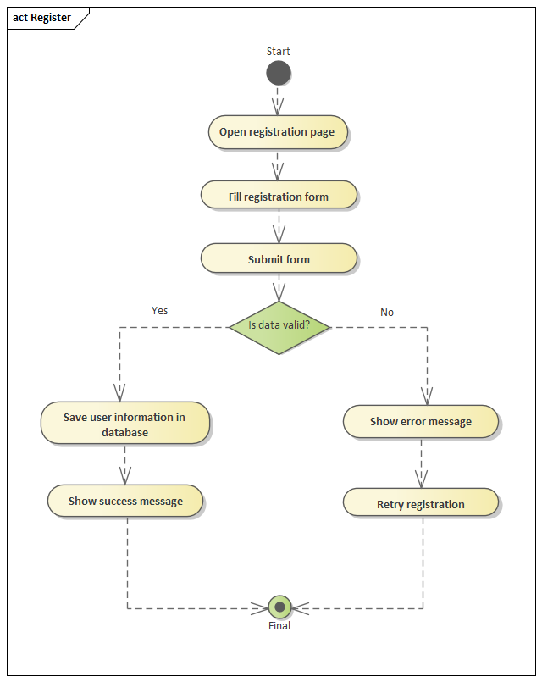
Figure 2.19 Activity Diagram reservation

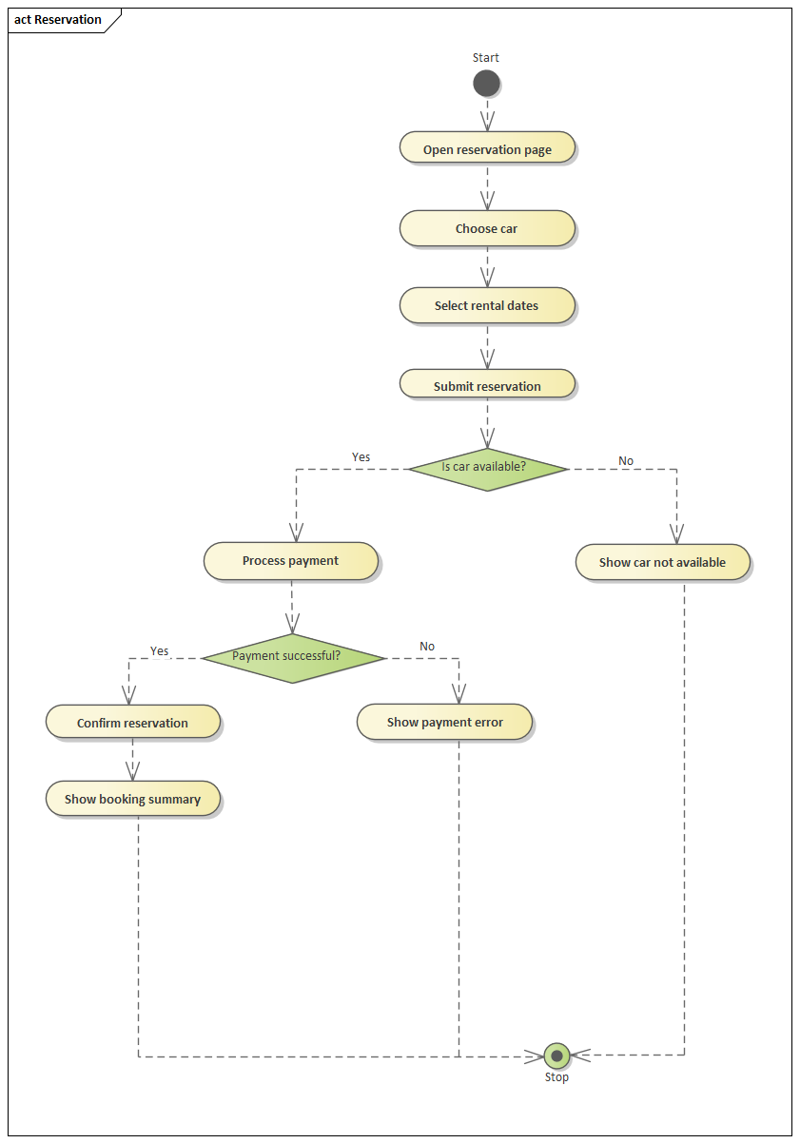
Figure 2.20 Activity Diagram update profile
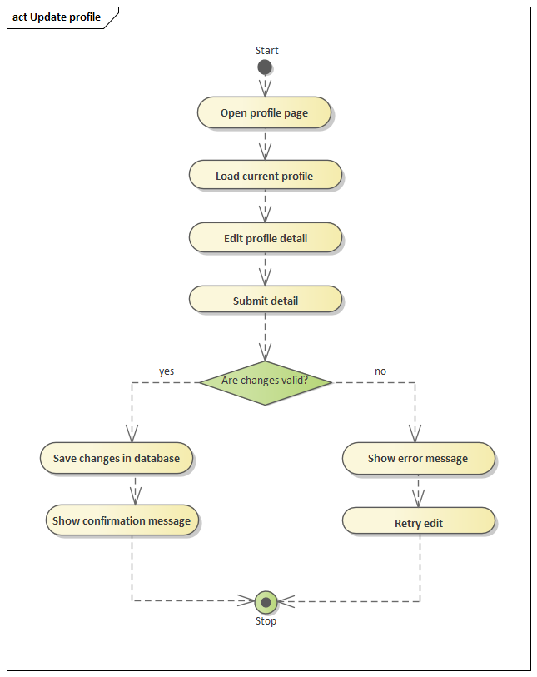
Figure 2.21 Activity Diagram view feedback

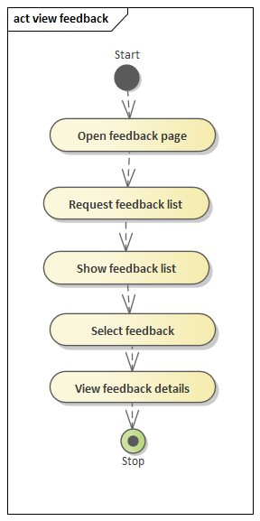Figure 2.22 Activity Diagram vie report

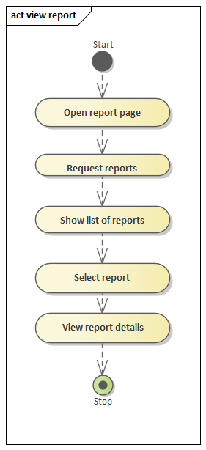

Figure 2.23 Activity Diagram send feedback
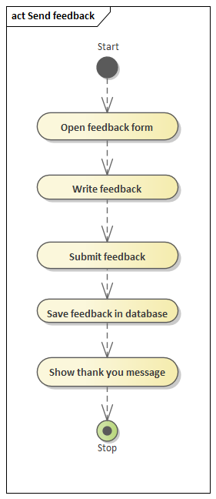

2.6.6.4. State Chart Diagram

Figure 2.24 State Chart diagram for browse car

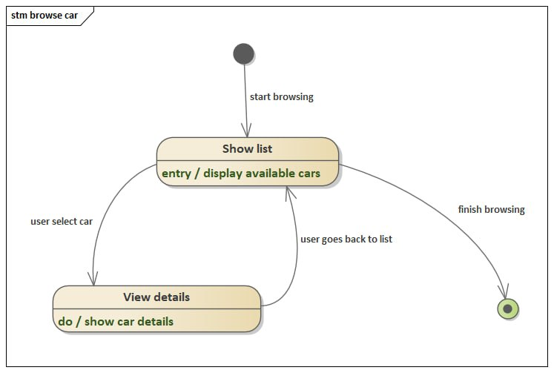
Figure 2.25 State Chart diagram for login
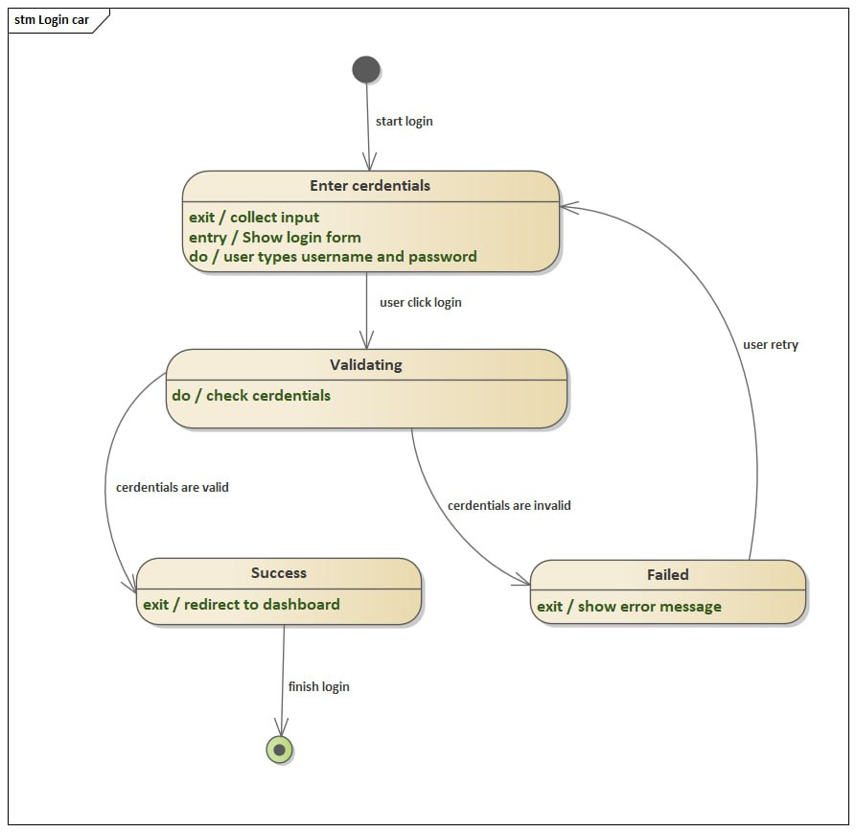
Figure 2.26 State Chart diagram for manage report
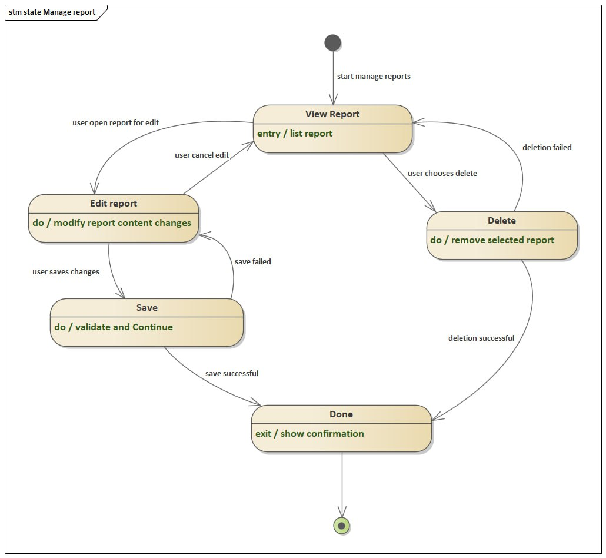
Figure 2.27 State Chart diagram for manage user account
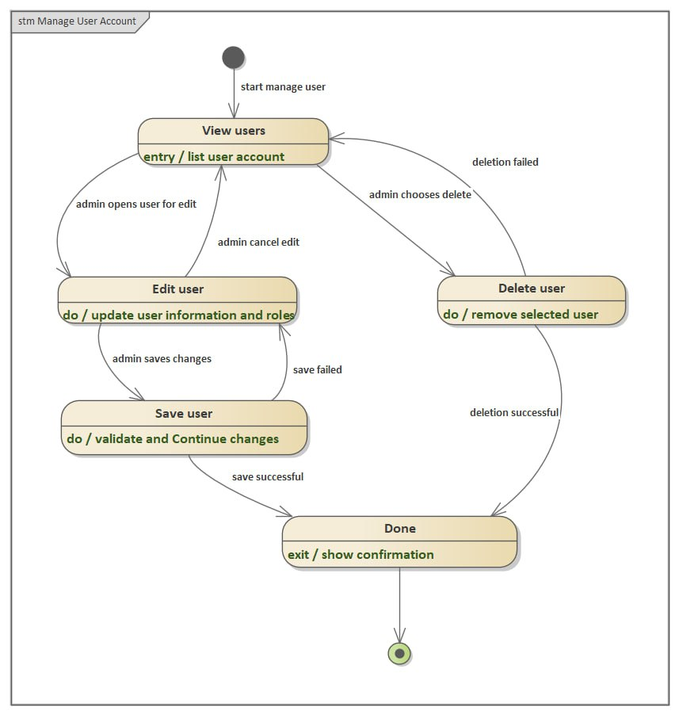
Figure 2.28 State Chart diagram for Reservation
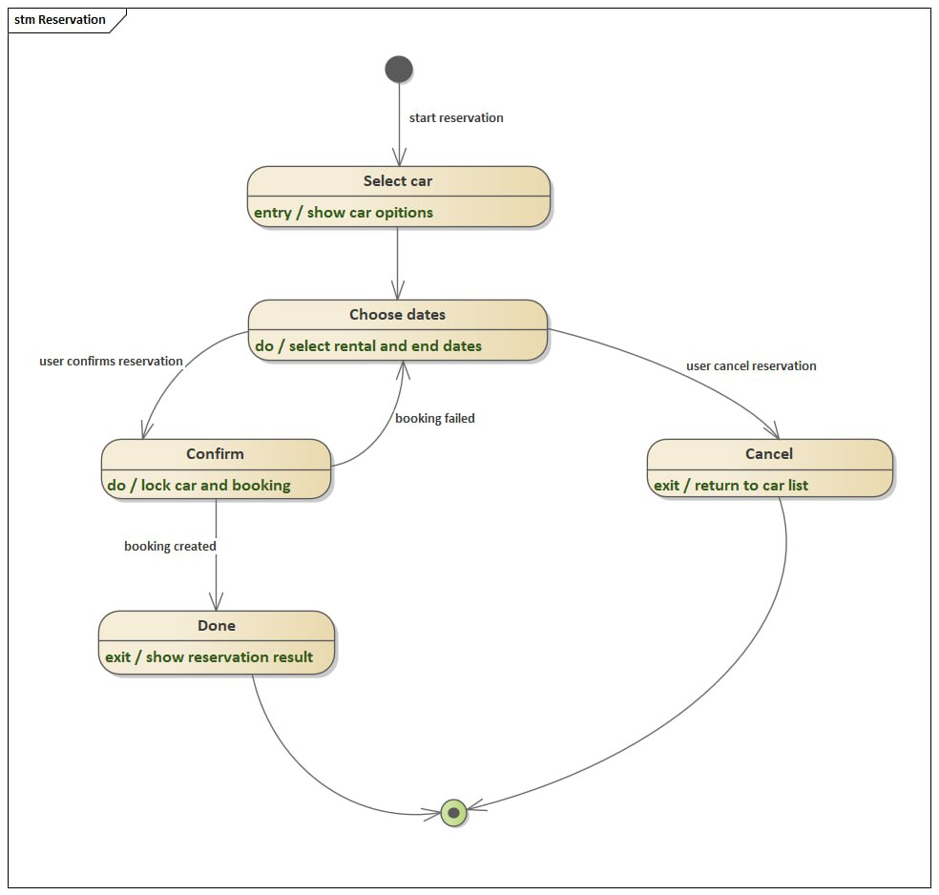
Figure 2.29 State Chart diagram for send Feedback
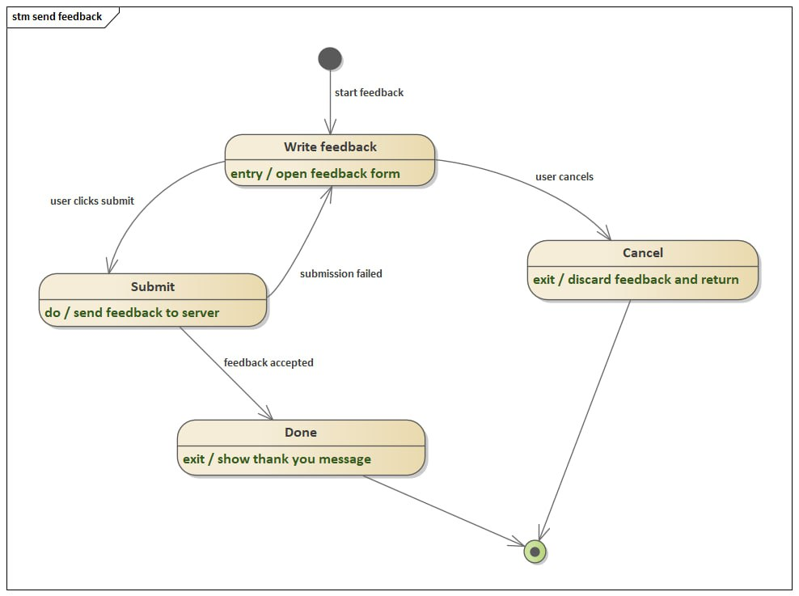
Figure 2.30 State Chart diagram for update profile
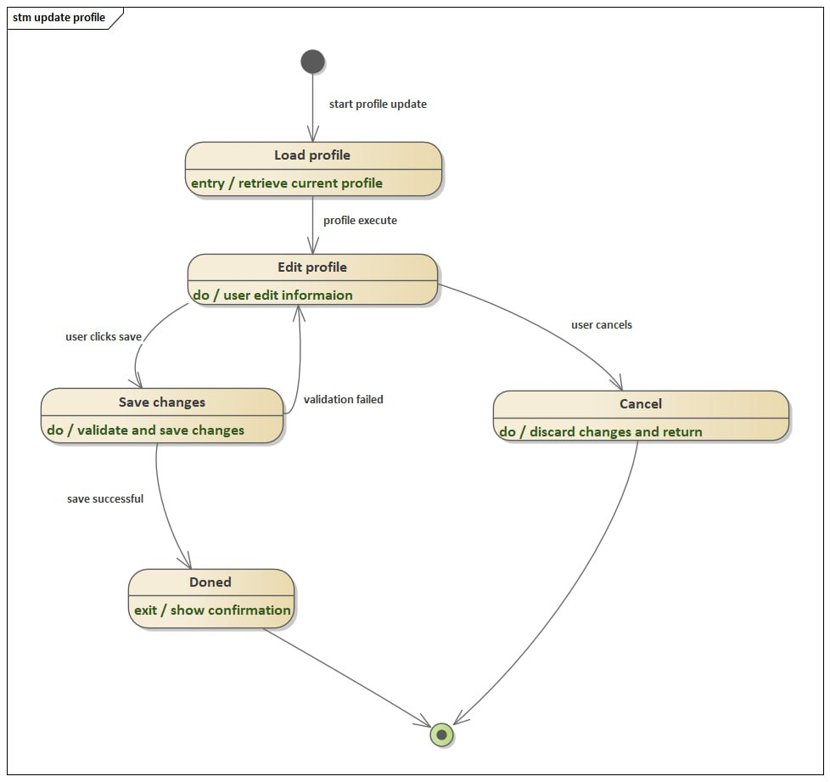
Figure 2.31 State Chart diagram for view feedback
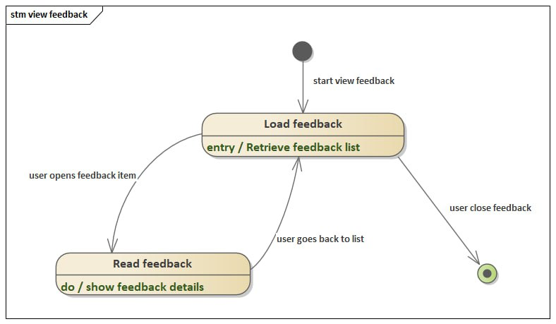
Figure 2.32 State Chart diagram for view report
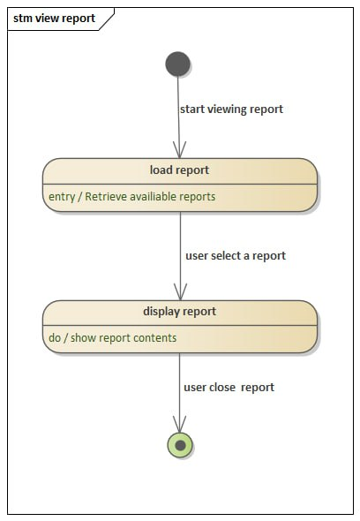
Figure 2.33 State Chart diagram for register
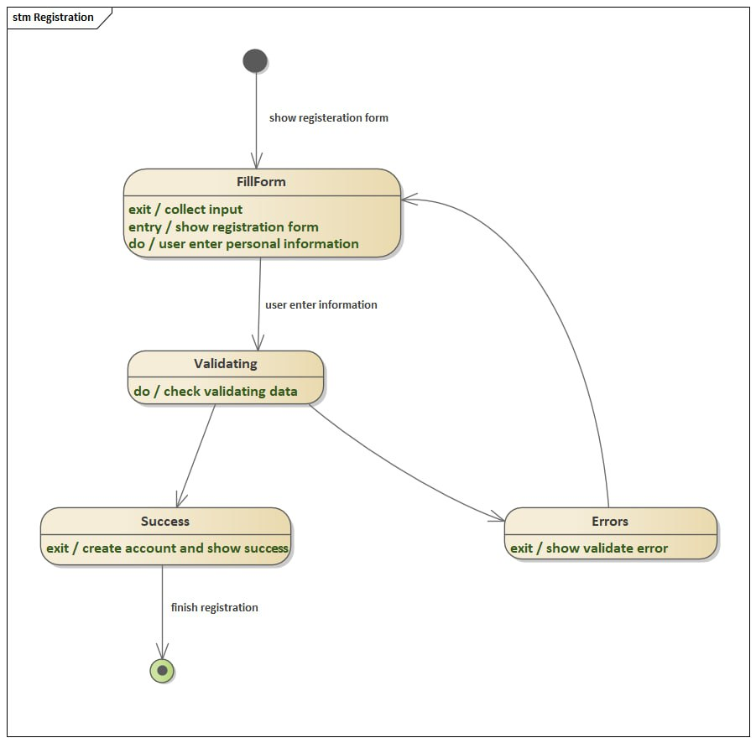

2.6.6.5. Class Diagram
Figure 2.34 Class Diagram

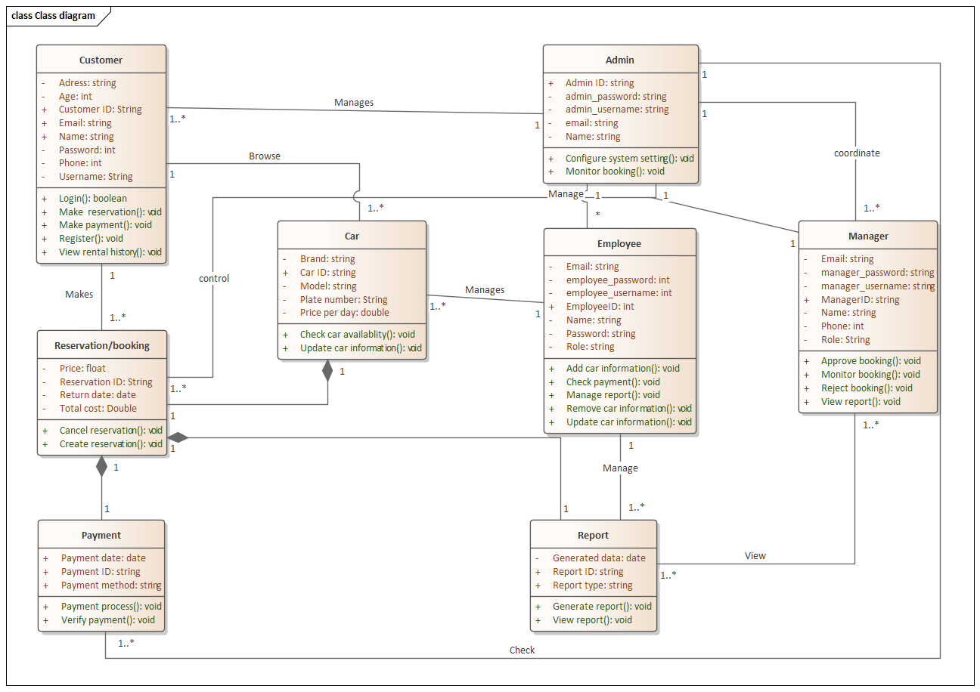

2.6.6.6. User Interface Prototyping
Figure 2.35 Prototype

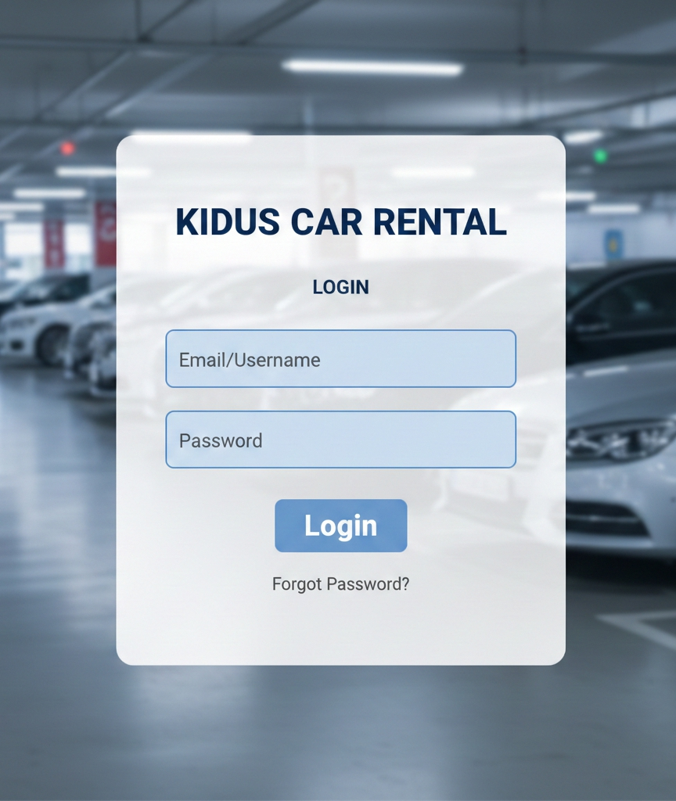

Chapter Three: Database Design

3.1. Conceptual Database Design of the New System

3.1.1. Entities identification and Description
Entity Identification
- Manager
- Car
- Reservation
- Payment
- Employee
- Admin
- Customer
- Report
Entity Description
CUSTOMER
The Customer entity represents individuals who use the system to rent cars. Customers can create accounts, provide personal and contact information, and make car reservations.
CAR
The Car entity represents vehicles available for rental in the system. Each car has unique identification and pricing information and is managed by employees.
RESERVATION
The Reservation entity represents a booking made by a customer for a specific car. It records rental details such as cost and return date.
PAYMENT
The Payment entity stores information about payments made for reservations. A reservation may involve one or more payments using different payment methods.
EMPLOYEE
The Employee entity represents staff members responsible for managing cars and assisting with system operations.
MANAGER
The Manager entity represents supervisory staff who oversee payments, view reports, and control certain system operations.
ADMIN
The Admin entity represents system administrators who manage employees, managers, reservations, and overall system coordination.
REPORT
The Report entity represents system-generated reports used for monitoring bookings, payments, and system performance.

3.1.2. Attributes identification and description
Table 3.1 Attribute identification and description
Attributes |  | Description
CUSTOMER | customerID (PK) | Unique identifier for customer
CUSTOMER | firstname | Customer first name
CUSTOMER | lastname | Customer last name
CUSTOMER | name | Full name (composite)
CUSTOMER | age | Derived attribute from date of birth
CUSTOMER | email | Customer email address
CUSTOMER | phone | Customer phone number
CUSTOMER | customer_userName | Login username
CUSTOMER | customer_password | Encrypted login password
CUSTOMER | driving_licence_No | Customer driving license number
CUSTOMER | Address | Composite attribute
CUSTOMER | city | City of residence
CUSTOMER | state | State/region of residence
CAR | carID (PK) | Unique car identifier
CAR | plateNo | Vehicle plate number
CAR | brand | Car manufacturer
CAR | model | Car model
CAR | priceperday | Rental price per day
RESERVATION | reservationID (PK) | Unique reservation identifier
RESERVATION | returnDate | Car return date
RESERVATION | price | Base rental price
RESERVATION | totalcost | Total calculated rental cost
PAYMENT | paymentID (PK) | Unique payment identifier
PAYMENT | paymentdate | Date of payment
PAYMENT | paymentmethod | Payment type (cash, card, online)
EMPLOYEE | employeeID (PK) | Unique employee identifier
EMPLOYEE | firstname | Employee first name
EMPLOYEE | lastname | Employee last name
EMPLOYEE | name | Full name
EMPLOYEE | email | Employee email
EMPLOYEE | employee_username | Login username
EMPLOYEE | employee_password | Login password
EMPLOYEE | role | Job role (staff, support, etc.)
MANAGER | manager_username (PK) | Manager login username
MANAGER | manager_password | Manager login password
MANAGER | firstname | Manager first name
MANAGER | lastname | Manager last name
MANAGER | name | Full name
MANAGER | email | Manager email
MANAGER | phone | Manager phone number
MANAGER | role | Manager role
ADMIN | AdminID (PK) | Unique admin identifier
ADMIN | firstname | Admin first name
ADMIN | lastname | Admin last name
ADMIN | name | Full name
ADMIN | email | Admin email
ADMIN | phone | Admin phone number
ADMIN | admin_username | Admin login username
ADMIN | admin_password | Admin login password
ADMIN | role | Admin role
Table 3.2 entity,relation ship and cardinality description

Relationship | Entities Involved | Description | Cardinality
MAKE | CUSTOMER – RESERVATION | A customer makes one or more reservations | CUSTOMER (1) → RESERVATION (1..*)
RESERVE | RESERVATION – CAR | Each reservation is for one car | RESERVATION (1..*) → CAR (1)
HAVE | RESERVATION – PAYMENT | A reservation can have one or more payments | RESERVATION (1) → PAYMENT (1..*)
MANAGE | EMPLOYEE – CAR | Employees manage car details | EMPLOYEE (1) → CAR (*)
CONTROL | ADMIN – RESERVATION | Admin oversees reservations | ADMIN (1) → RESERVATION (*)
CHECK | MANAGER – PAYMENT | Manager verifies and checks payments | MANAGER (1) → PAYMENT (*)
COORDINATE | ADMIN – MANAGER | Admin coordinates managers | ADMIN (1) → MANAGER (1..*)
MANAGE | ADMIN – EMPLOYEE | Admin manages employees | ADMIN (1) → EMPLOYEE (*)

3.1.4. ER Diagrams
Figure 3.1 ER Diagram

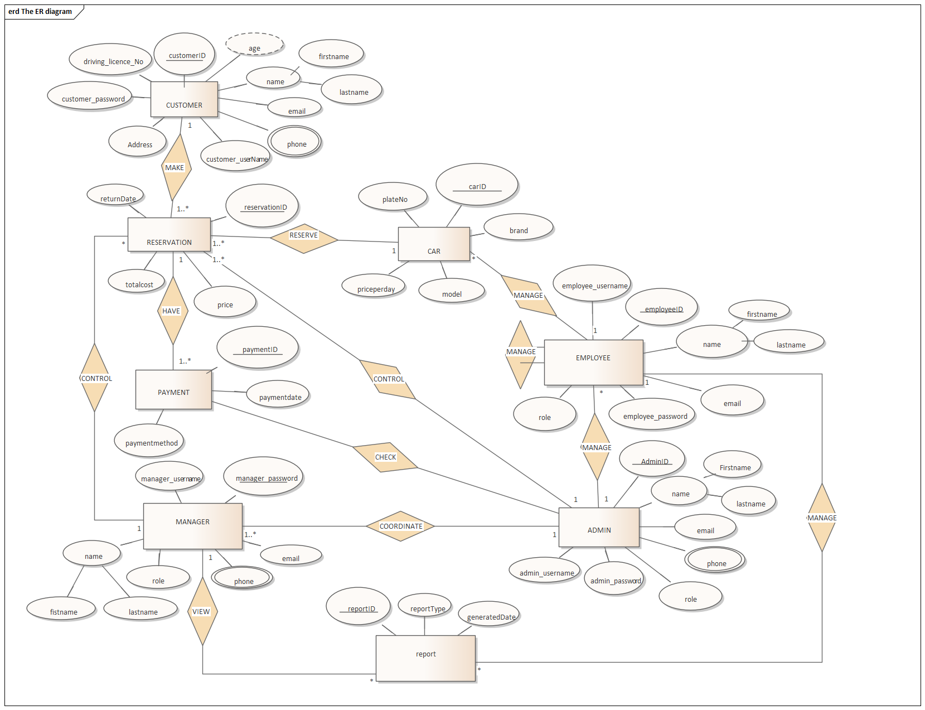

3.2. Logical Database Design of the New System

3.2.1. ER to Table Mapping
Figure 3.2 Table Mapping

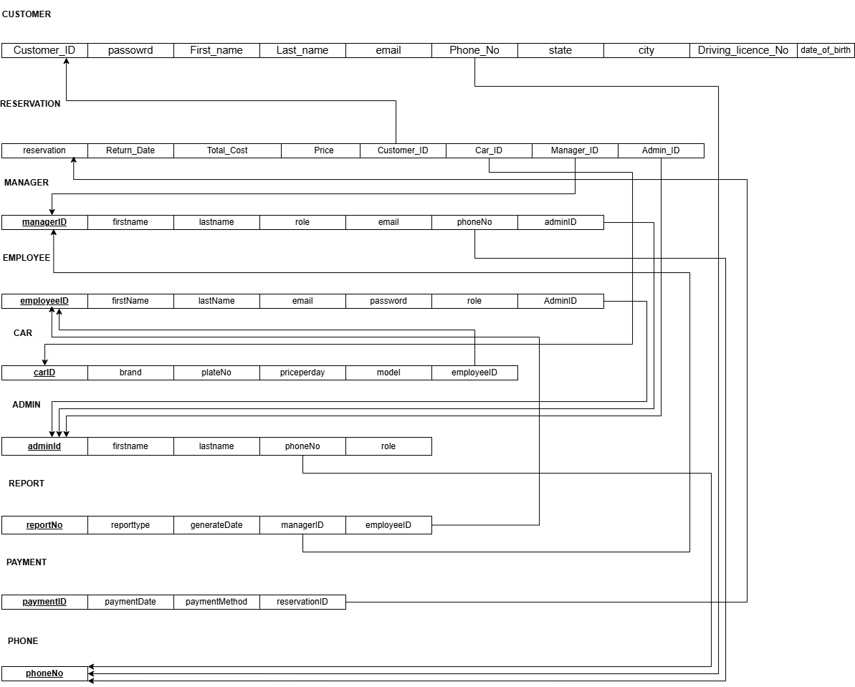

3.2.2. Validate Model using Normalization

3.2.2.1. First Normal Form (1NF)
CUSTOMER
-It doesn’t pass 1nf since phone can be multivalued. To fix it let’s decompose it in to two tables.
1 NF CUSTOMER
CUSTOMER_ID | FIRST_NAME | LAST_NAME | AGE | EMAIL | CUSTOMER_USERNAME | CUSTOMER_PASSWORD | ADDRESS | DRIVING_LICENCE_No
20 | Abel | Tesfaye | 25 | abel@gmail.com | Abel25 | Pass1 | Addis ababa | ET-DL-2019-001
35 | Kebede | Mulu | 30 | kebede@gmail.com | Kebede30 | Pass2 | Adama | ET-DL-2018-002

1 NF CUSTOMER_PHONE
CUSTOMER_ID | PHONE_No
20 | 0911234001
20 | 09365897
35 | 0925473645

ADMIN

ADMIN_ID | FIRST_NAME | LAST_NAME | ADMIN_USERNAME | ADMIN_PASSWORD | PHONE_No | ADMIN_ROLE
A01 | Tadesse | Bekele | admin1 | Adminpass1 | 0911234001 | SUPER
A02 | Abriham | kasa | admin2 | Adminpass2 | 091111111 | Super
-It violates 1 nf since PHONE_No is multivalued. We can fix it by creating a new table for the multivalued attribute.
Decomposition to 1 nf
1 NF ADMIN
ADMIN_ID | FIRST_NAME | LAST_NAME | ADMIN_USERNAME | ADMIN_PASSWORD | ADMIN_ROLE
A01 | Tadesse | Bekele | admin1 | Adminpass1 | SUPER
A02 | Abriham | kasa | admin2 | Adminpass2 | Super

1 NF ADMIN_PHONE
ADMIN_ID | PHONE _No
A01 | 0911234001
A02 | 091111111

MANAGER
MANAGER_ID | FIRST_NAME | LAST_NAME | MANAGER_USERNAME | MANAGER_PASSWORD | EMAIL | ROLE | PHONE_No | ADMIN_ID
M01 | Selam | yohannis | Mgr1 | Mgrpass1 | Selam@gmail.com | manager | 0911232523 | Admi01
-It violates 1 NF since PHONE_No is multivalued. We can fix it by creating a new table for the multivalued attribute.
1 NF MANAGER
MANAGER_ID | FIRST_NAME | LAST_NAME | MANAGER_USERNAME | MANAGER_PASSWORD | EMAIL | ROLE | ADMIN_ID
M01 | Selam | yohannis | Mgr1 | Mgrpass1 | Selam@gmail.com | manager | Admi01

1 NF MANAGER PHONE
MANAGER_ID | PHONE_No
M01 | 0911232523

CAR
CAR_ID | BRAND | PLATE_No | PRICE_PER_DAY | CAR_MODEL | EMPLOYEE_ID
C01 | toyota | aa-12345 | 1500 | corolla | E01

-Already in 1 NF.
RESERVATION
RESERVATION_ID | RETURN_DATE | PRICE | TOTAL_COST | CUSTOMER_ID | MANAGER_ID | CAR_ID | ADMIN_ID
-It is already in 1 NF since there is no repetition.
EMPLOYEE
Employee_id | Firstname | lastname | Employee_username | Employee_Password | Email | Role | Phone_no

It is not in 1 NF since phone_no can be multivalued. To fix this we decompose it.
1 NF Employee
Employee_id | Firstname | lastname | Employee_username | Employee_Password | Email | Role

1 NF Employee Phone
Employee_ID | Phone_no

Payment
Payment_ID | Payment_date | Payment_Method | Reservation_ID

No Decomposition needed.
Already it is in 1NF, 2NF, 3NF, BCNF and 4NF.
REPORT

Report_ID | Repot_Type | Generate_Date | Manager_ID | Employee_ID

The table is already in 1NF, 2NF, 3NF, BCNF and 4NF Since it holds no violation for respective the rules.
Table 3.3 Tables for 1 NF

3.2.2.2. Second Normal Form (2NF)
Customer
It passes 2nf since there is no partial dependency in both tables.
ADMIN
-Both tables pass 2 NF since there is no partial dependency .
Manager
-Both tables are in 2 NF since there is no partial dependency .
CAR
-Also it is in 2 NF since there is no partial dependency.
RESERVATION
-It is also in 2 NF since it has no partial dependency.
EMPLOYEE
it is in 2NF since there is no partial dependency tables .
Payment
No Decomposition needed.
Already it is in 1NF, 2NF, 3NF, BCNF and 4NF.
REPORT
The table is already in 1NF, 2NF, 3NF, BCNF and 4NF Since it holds no violation for respective the rules.

3.2.2.3. Third Normal form (3NF)
Customer
-it also passes 3NF since there is no any transitivity.
BCNF
-NO non key attribute determines a part of CK or a CK itself so both tables pass this.
ADMIN
-They also pass 3 NF because there is no transitivity.
BCNF
-Since all determinants are candidate keys they pass it.
Manager
-They are also in 3 NF since there is no transitivity on both of them.
BCNF
-Both tables pass since only determinant is key.
CAR
-It fails to pass 3 NF since there is transitivity . CAR_ ID CAR_MODEL BRAND
-So let’s decompose it by adding MODEL_ID in both tables which will be decomposed & then keeping CAR_MODEL & BRAND in other table.
3 NF CAR
CAR_ID | PLATE_No | PRICE_PER_DAY | EMPLOYEE_ID | MODEL_ID
C01 | aa-12345 | 1500 | E01 | Mc00

3 NF CAR MODEL
MODEL_ID | CAR_MODEL | BRAND
Mc00 | corolla | toyota

BCNF
-Since all determinants are keys both pass
RESERVATION
-it violates 3 NF since price and reservation is the same as price per day for car. This suggests price is redundant and is transitively dependent on reservation id via car id(reservation id car id price). This violates 3 NF.
- Total cost= price*number of days
-the number of days can be calculated from a started date (missing in reservation table) and return date.
-WE can fix it by avoiding price and total cost. Since the former is price per day for car and the latter is derivable. At last we add start date.
3 NF

RESSEVATION_ID | Return date | Starting Date | CUSTOMER_ID | MANAGER_ID | CAR_ID | ADMIN_ID
EMPLOYEE
It is un an 3NF since there is transitivity in the table
Since Every determinant is the candidate key it’s also in BCNF.
Table 3.4 Tables for 3 NF

3.2.2.4. Other NF
Customer
4 NF
-It passes since there are no any attribute that are independently multivalued.
ADMIN
4 NF
-Both tables have no multivalued dependency so they pass.
Manager
4 NF
-Both pass since there are no multivalued dependencies .
CAR
-Both pass since there is no multivalued dependencies .
RESERVATION
Now it is in BCNF and 4 NF since there is no violation of respective rules.
EMPLOYEE
Also since there is no multivalued dependency it’s in 4 NF

3.2.3. Relational Schema with Referential Integrity after normalization
Figure 3.2 schema after normalization

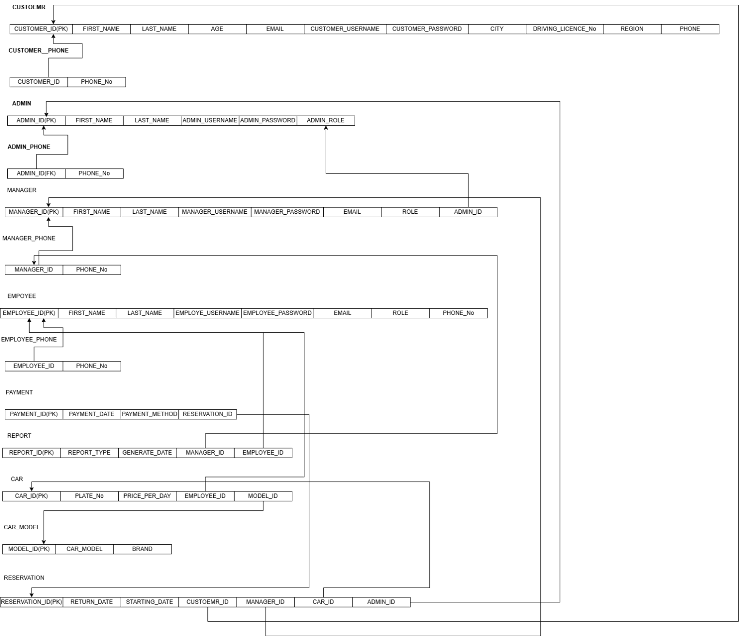

3.3. Physical Database Design of the New System

3.3.1. Physical Design Strategy
In this system, the database is divided into many tables to store different types of information. For example, one table is used to store customer details, another table is used to store car information, and other tables store booking, payment, and employee records. Each table is created to hold only one type of data, which makes the system easier to understand and manage.
Each record in the database has a unique identification number. This helps the system find specific information quickly, such as a particular customer or a specific booking. The database is designed to allow fast searching when users check available cars, make reseravtion, or view rental history.
The database structure also helps keep data correct and consistent. Important information cannot be left empty, and repeated or wrong data is reduced. The design allows the system to update information easily when cars are returned, payments are made, or customer details are changed.
Overall, this physical design strategy makes sure the database works efficiently, stores data safely, and supports smooth operation of the Online Car Rental System.

3.3.2. Hardware Implementation
The Online Car Rental System is implemented using:
- A Server computer where the database and application are installed.
- The Database Server stores all rental data and processes requests.
- Client devices (desktop computers, laptops, and smartphones) are used by customers and staff.
- A Network Connection is implemented to allow communication between users and the server.
- Backup Storage devices are implemented to store copies of the database.
- Power backup is used to protect the system from sudden power failure.
This hardware implementation allows the system to run continuously and reliably.

Chapter Four: System Design

4.1. Introduction
The Online Car Rental System is a web-based software application that provides a modern solution for renting cars online. Instead of relying on manual processes such as phone calls, paperwork, or physical visits to rental offices, customers can now access the system through any web browser.
The system allows customers to browse cars, make reservations, and pay securely online. At the same time, administrators can manage cars, monitor bookings, update rental prices, and manage reports. Because it is web-based, the system is accessible from anywhere, at any time, making it highly convenient for both customers and rental companies.
This design ensures that the system is user-friendly, secure, and scalable, supporting future growth as the number of cars and customers increases. It also reduces human errors, improves efficiency, and enhances customer satisfaction by providing a smooth and reliable rental experience.

4.2. Purpose of the System
The purpose of the Online Car Rental System is to automate and centralize the car rental process. It aims to:
- Provide customers with a fast, easy, and transparent way to rent cars online.
- Eliminate manual errors such as double-bookings or lost records.
- Improve efficiency for rental companies by offering digital management tools.
- Ensure secure handling of customer data and online payments.
- Support business growth by allowing the system to handle more cars, customers, and transactions without performance issues.
In short, the system connects customers and rental companies through a secure, web-based platform that saves time, reduces costs, and improves service quality.

4.3. Design Goals
The design of the system is guided by several important goals:
- Usability – The interface should be simple and user-friendly, so customers and administrators can use it without difficulty.
- Security – Sensitive information such as passwords, customer data, and payment details must be protected using encryption and secure authentication.
- Reliability – The system should prevent double-bookings, handle errors gracefully, and ensure that data remains consistent.
- Scalability – The system should support growth, handling more cars, customers, and transactions as the business expands.
- Maintainability – The system should be easy to update, extend, and fix when new requirements or technologies arise.
- Performance – Searching for cars, booking rentals, and processing payments should be fast and responsive.
- Accessibility – Since it is web-based, the system should be accessible from different devices (PCs, laptops, tablets, smartphones).

4.4. Current Software Architecture
At present, most car rental services operate using manual. Customers often need to visit rental offices in person, make phone calls that provide limited functionality. These approaches create several challenges:
- Manual Data Handling – Customer details, car availability, and booking records are often stored in paper files or simple spreadsheets. This increases the risk of errors, duplication, and data loss.
- Limited Customer Access – Customers cannot easily check real-time car availability or pricing. They must depend on staff to provide information, which slows down the process.
- Booking Conflicts – Without a centralized system, double-bookings or overlapping reservations can occur, leading to customer dissatisfaction.
- Lack of Security – Sensitive customer data and payment details are not always protected with strong security measures, leaving them vulnerable.

4.5. Proposed Software Architecture

4.5.1. Subsystem Decomposition
The main subsystems are:
- User Management Subsystem
This subsystem handles user registration, login, and profile management. It manages different user roles such as customer, employee, manager, and admin.
- Car Management Subsystem
This subsystem manages car information. It allows employees to add, update, and remove car details. Customers can view available cars and their details.
- Reservation Subsystem
This subsystem handles car booking. Customers can make reservations, and managers can approve or reject bookings. It also checks car availability.
- Payment Subsystem
This subsystem manages payment processing and payment verification. It ensures that reservations are paid before they are confirmed.
- Feedback and Reporting Subsystem
This subsystem allows customers to send feedback. Managers and admins can view reports about.

4.5.2. Component Diagram
Figure 4.1 Component Diagram for login

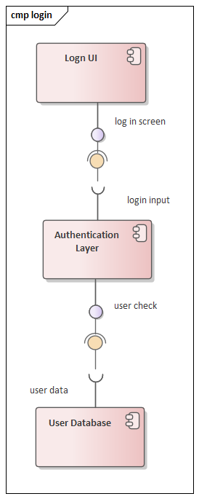Figure 4.2 Component diagram for manage report

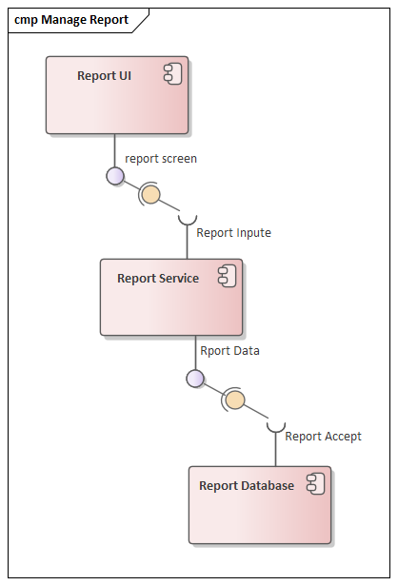
Figure 4.3 Component diagram for send feedback
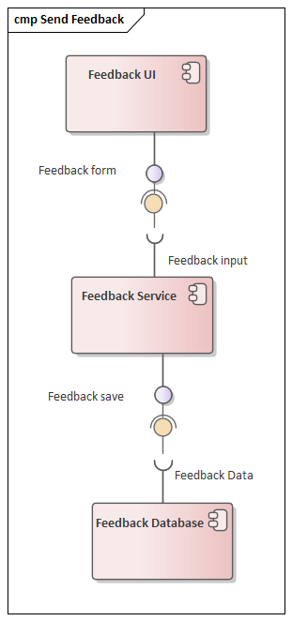
Figure 4.4 State Chart diagram for view feedback
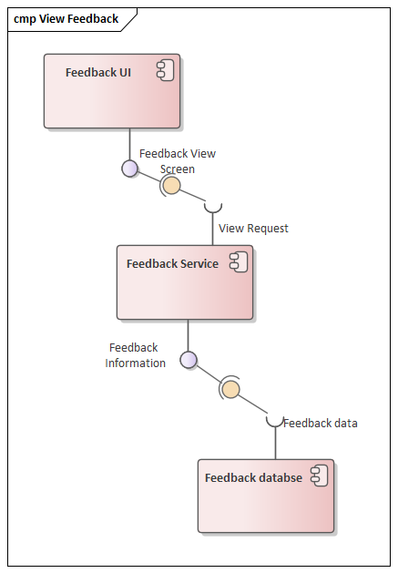
Figure 4.5 State Chart diagram for view report
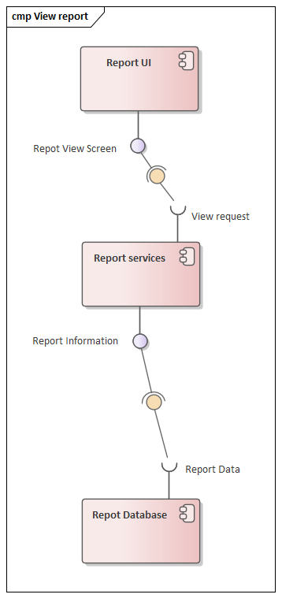

4.5.3. Deployment Diagram
Figure 4.7 Deployment Diagram
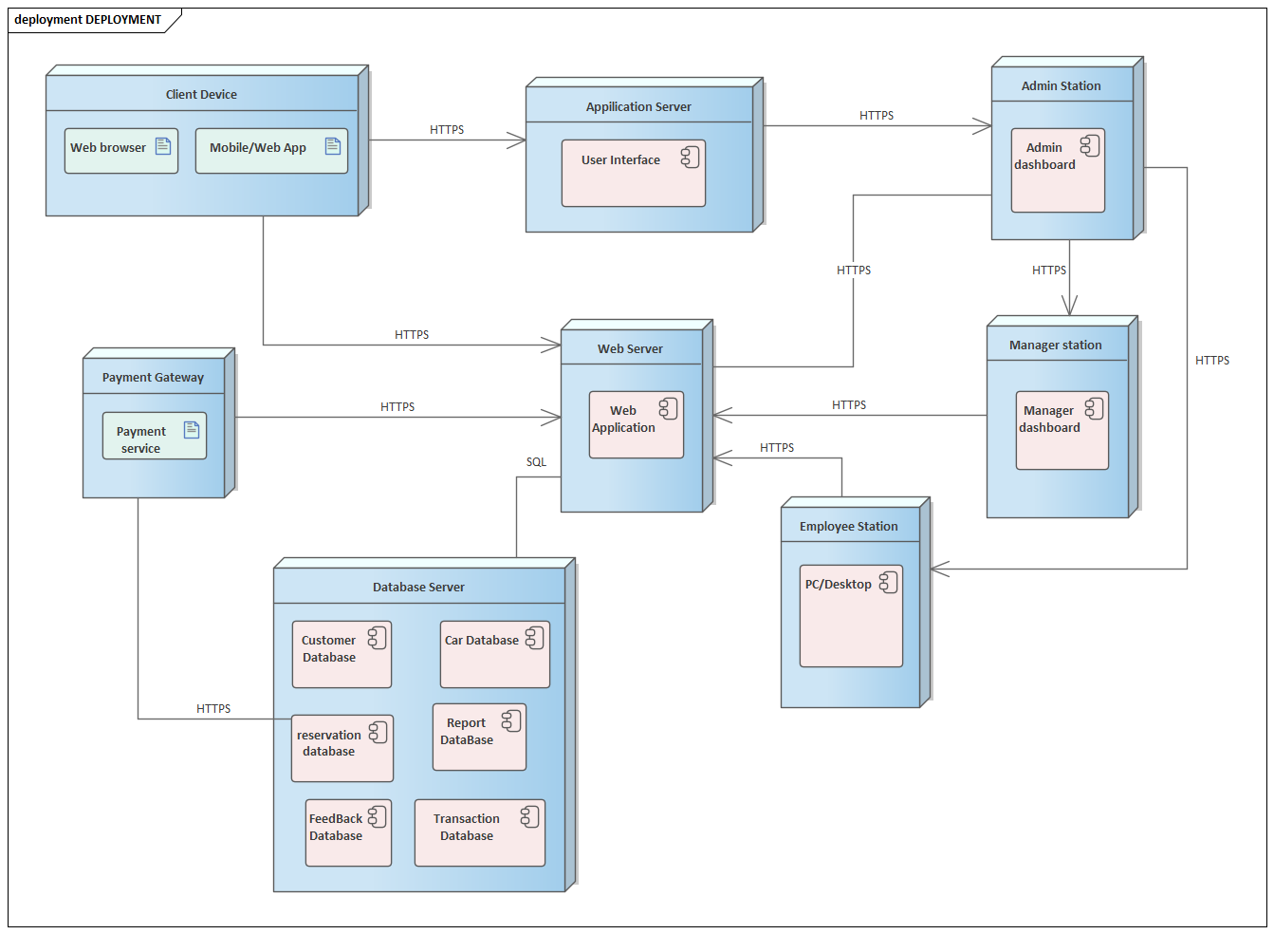

4.5.4. Database Diagram
Figure 4.8 database diagram
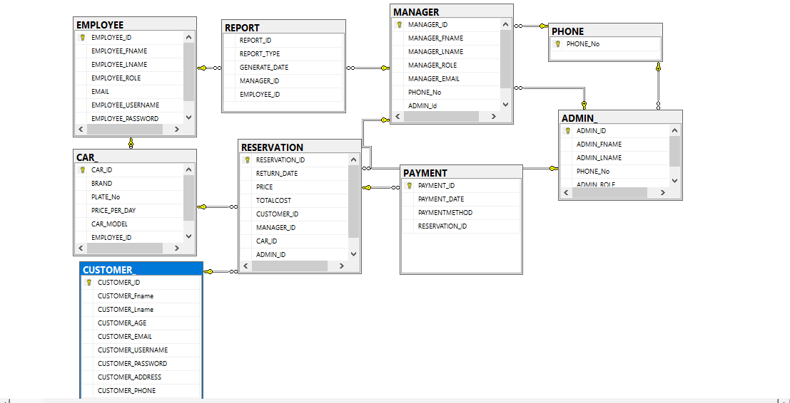

4.5.5. Persistent Data Management
- Centralized Database
- All data is stored in a relational database (SQL).
- Entities include Customer, Car, Reservation, Admin, Employee, Report, Manager and Payment.
- Relationships between tables ensure consistency (e.g., one customer can have many reservations, each reservation linked to a car and payment).
- Data Normalization
- The database is normalized to avoid duplication and redundancy.
- Ensures that updates are consistent across the system.
- Example: Car details are stored once in the Car table and referenced in the Rental table.
- Transaction Management
- Transactions ensure that operations such as booking and payment are completed fully or not at all.
- Prevents issues like double-bookings or incomplete payments.
- Example: If a payment fails, the booking is rolled back to maintain accuracy.
- Backup and Recovery
- Regular backups protect against data loss due to system failures or crashes.
- Recovery procedures restore data quickly to minimize downtime.
- Security of Data
- Sensitive information such as passwords and payment details is encrypted before storage.
- Access control ensures only authorized users (admins) can view or modify certain records.
- Scalability and Performance
- The database is designed to handle increasing numbers of customers, cars, and transactions.

4.5.6. Access Control and Security
This System supports four types of users: Customer, Employee, Admin, and Manager. Each user has access only to the features shown in the use case diagram.
- Customers can register, log in, browse cars, make reservations, pay online, view rental history, send feedback, and manage their profile.
- Employees can manage car information (add, update, remove cars).
- Admins can manage user accounts, approve or reject reservations, check payments, view feedback, and generate reports.
- Managers can view feedback and reports only.
All users must log in before using the system. The login is included in most actions, and logout is available after login. The system uses role-based access control to make sure users only see and use the features allowed for their role.
To keep data safe:
- Passwords are encrypted.
- Payments are handled through secure gateways.
- The system uses HTTPS for secure communication.
- Important actions are logged for tracking.
This setup ensures that the system is secure, reliable, and easy to manage.

4.5.7. Global Software Control
Global software control in the Online Car Rental System refers to the overall mechanisms that keep the system stable, consistent, and reliable across all the activities. These controls are not tied to a single feature but apply to the entire system to ensure smooth operation.
The system includes error handling that detects invalid inputs, failed payments, or booking conflicts and responds with clear messages to guide users. Logging and monitoring are applied to record important activities such as reservations, payments, and account changes, which helps administrators track usage and identify problems. Transaction management ensures that reservation and payment processes are completed fully or rolled back if any step fails, keeping the data consistent.

4.5.8. Boundary Conditions
The system can handle multiple customers making reservations at the same time, but there are limits to prevent overload. For example, the database has a maximum capacity for storing car records, customer accounts, and transaction history. If these limits are reached, administrators may need to expand resources.
Response time is also controlled. The system is expected to process browse, reservation, and payments quickly, usually within a few seconds. If too many users are online at once, performance may slow down, and scaling measures will be required.
Other boundaries include session timeouts to protect security, restrictions on user actions based on roles (Customer, Employee, Admin, Manager), and backup schedules to prevent data loss. These conditions make sure the system continues to work reliably within its defined limits.

4.6. Refined ER Diagram
Figure 4.9 Refined ER Diagram

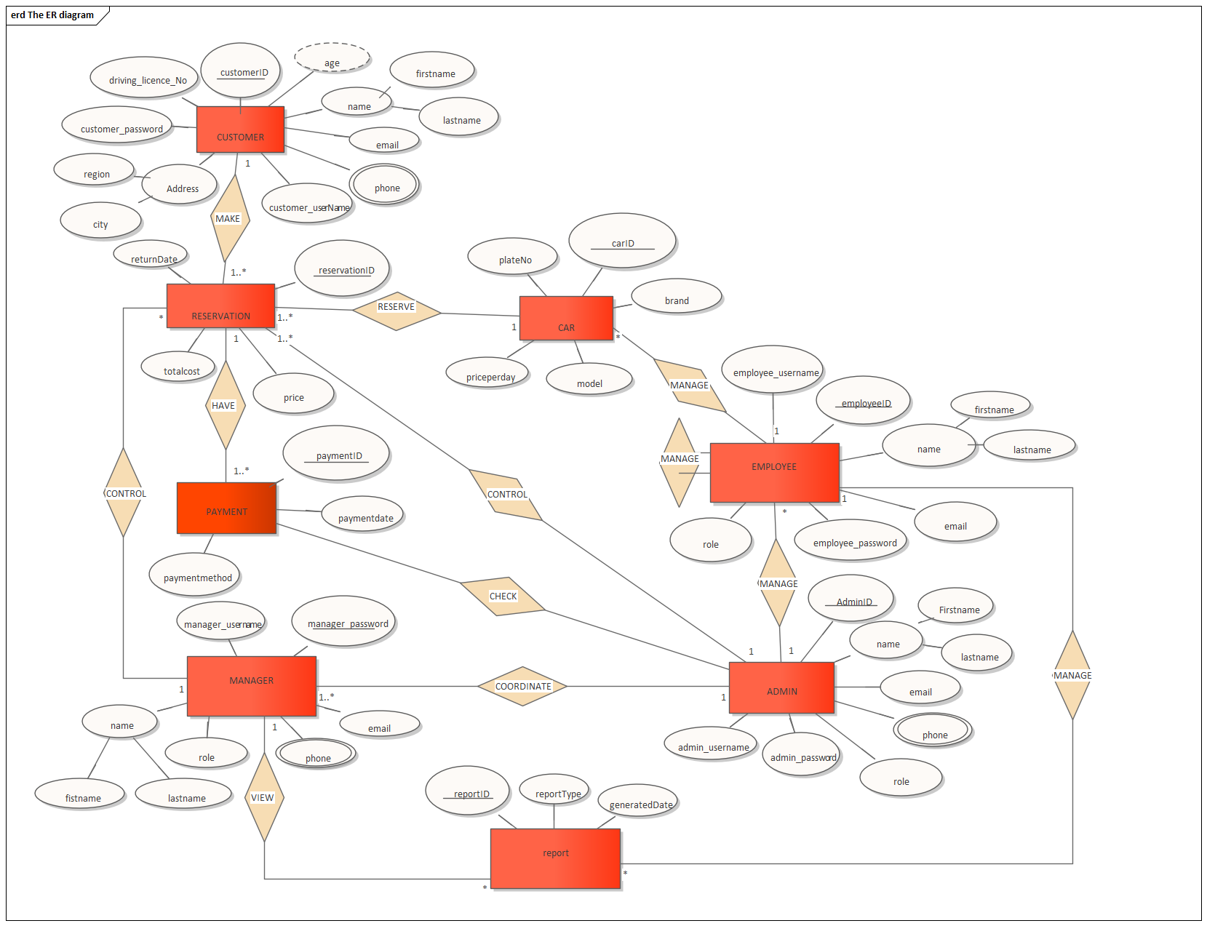

Chapter Five: Implementation and Testing

5.1. Test Procedure
Each prototype version is tested by both developers and users to identify errors, missing features, or usability issues. The procedure begins with unit testing of individual modules such as login, reservation, and payment. Then, integration testing ensures that modules work together correctly. After that, system testing checks the entire application against requirements. Finally, user acceptance testing is performed, where customers, employees, admins, and managers interact with the prototype to confirm that it meets their needs. Feedback from each test cycle is used to refine the next prototype until the system is stable and complete.

5.2. User Manual Preparation
In the prototyping approach, the user manual is prepared alongside system development. As new features are added and refined, the manual is updated to reflect the latest version. The manual provides simple, step-by-step instructions for all user roles:
- Customers learn how to register, log in, browse cars, make reservations, and pay online.
- Employees are guided on managing car records.
- Admins are instructed on managing accounts, reservations, and reports.
- Managers are shown how to view feedback and reports. Because the system evolves through prototypes, the manual is also refined based on user feedback to ensure clarity and ease of use.

5.3. Training and Installation
The Online Car Rental System is a web-based application, so installation is simple. The system is placed on a server and made available through a web browser. Once installed, users can access it online without needing to set up extra software on their computers.
Training is provided to help different users understand how to use the system. Customers are shown how to register, log in, browse cars, make reservations, and pay online. Employees are trained on how to manage car information. Administrators learn how to manage accounts, reservations, and reports, while managers are guided on viewing feedback and reports.
The training is done step by step, using demonstrations and practice sessions, so that all users can become comfortable with the system before it is fully launched.

5.4. Startup Strategy
First, the system is launched in a trial phase with a small group of users. This allows customers, employees, and administrators to try the system in real conditions and provide feedback. Any problems or improvements identified during this stage are corrected before the full rollout.
After the trial phase, the system is fully deployed for all users. Training sessions and user manuals help customers and staff become familiar with the system. Backup and recovery plans are prepared to handle unexpected issues, and continuous monitoring ensures that the system runs reliably.
This step-by-step startup strategy makes the transition from the old manual process to the new online system smooth, secure, and user-friendly.

Chapter Six: Conclusion and Recommendation

6.1. Conclusion
The Online Car Rental System was developed to solve the major challenges faced by car rental companies that rely on manual processes. Traditional paper-based systems are slow, prone to errors, and make it difficult to manage reservations, payments, and customer records efficiently. By introducing an automated online platform, this project provides a modern solution that improves both customer experience and organizational performance.
Using the prototyping software development method, the system was built step by step with continuous feedback from stakeholders. This approach allowed the team to refine features such as customer registration, car browsing, reservation, payment, and rental history management until they became user-friendly and reliable. Employees now have tools to manage car information easily, administrators can oversee reservations and payments securely, and managers can access reports and feedback for better decision-making.
The system achieves its general objective of making car rental faster, easier, and more accurate. It also meets specific objectives such as reducing paperwork, minimizing human errors, protecting customer data, and generating useful reports. Beyond solving current problems, the system creates opportunities for future growth by supporting scalability, mobile access, and integration with more payment options.
In conclusion, the Online Car Rental System is not only a technical achievement but also a practical solution that transforms the way car rental services are delivered. It strengthens customer trust, improves efficiency, and supports the long-term success of the organization.

6.2. Recommendation
First, security measures should be continuously strengthened. While the system already uses login and basic encryption, future versions should adopt advanced authentication methods such as two-factor verification and stronger password policies. This will protect sensitive customer data and payment information against modern cyber threats.
Second, the system should be expanded to include a mobile application. Many customers prefer using smartphones for quick access, and a mobile app would make reservations, payments, and car browsing more convenient. This would also increase customer satisfaction and broaden the system’s reach.
Third, integration with multiple payment gateways is recommended. Currently, the system supports basic online payment, but adding more options such as mobile money services, debit/credit cards, and international payment platforms will give customers flexibility and reduce transaction failures.
Fourth, the system should be designed to handle future scalability. As the company grows, the number of cars, customers, and transactions will increase. The database and application should be upgraded to handle larger volumes without affecting performance.
Fifth, continuous training and support should be provided to staff and customers. Training sessions will help employees manage cars and reservations effectively, while customers will learn how to use the system confidently. Regular updates to the user manual will also ensure that users stay informed about new features.
Finally, maintenance and monitoring should be carried out regularly. This includes fixing bugs, updating software components, and improving usability based on feedback. Continuous monitoring will help detect issues early and keep the system reliable.
By following these recommendations, the Online Car Rental System can remain secure, user-friendly, and adaptable to future needs, ensuring that it continues to serve both customers and the organization effectively.

6.3. Reference
1. "Software Engineering: A Practitioner's Approach" by Roger S. Pressman
2 .IEEE Recommended Practice for Software Requirements Specifications (IEEE Std 830-1998)
3. IEEE.org - For official standards like IEEE 830.
4.Database System Conc... by Abraham Silberschatz
5. Kidus Car Rental System (2018). Practical requirements and business rules gathered during interviews and observations.
6.Lecture notes and guidance from instructors Ms. Senedu G. and Ms. Fozia A., Wachemo University, Department of Software Engineering (2018 E.C).

6.4. Appendix
CREATE DATABASE ONLINE_CAR_RENTAL_SYSTEM
USE ONLINE_CAR_RENTAL_SYSTEM

CREATE TABLE PHONE
(
PHONE_No INT PRIMARY KEY NOT NULL
);

CREATE TABLE CUSTOMER_
(
CUSTOMERID INT IDENTITY(20,15) PRIMARY KEY,
FIRSTNAME VARCHAR(30) NOT NULL,
LASTNAME VARCHAR(30) NOT NULL,
AGE INT NOT NULL CHECK (AGE >=21),
EMAIL VARCHAR(30),
CUSTOMER_USERNAME VARCHAR(20),
CUSTOMER_PASSWORD VARCHAR(20),
REGION VARCHAR(50) NOT NULL,
CITY VARCHAR(50) NOT NULL,
DRIVING_LICENCE_No VARCHAR(20) NOT NULL,
PHONE_NO INT REFERENCES PHONE (PHONE_NO));

CREATE TABLE ADMIN
(
ADMIN_ID VARCHAR(20) PRIMARY KEY,
FIRSTNAME VARCHAR(30),
LASTNAME VARCHAR(30),
ADMIN_USERNAME VARCHAR(20),
ADMIN_PASSWORD VARCHAR(20),
PHONE_No INT REFERENCES PHONE(PHONE_NO),
ADMIN_ROLE VARCHAR(20),
);

CREATE TABLE MANAGER
(
MANAGER_ID varchar(20) PRIMARY KEY,
FIRSTNAME VARCHAR(30),
LASTNAME VARCHAR(30),
MANAGER_USERNAME VARCHAR(20),
MANAGER_PASSWORD VARCHAR(20),
ROLE VARCHAR(20),
EMAIL VARCHAR(30),
PHONE_No INT REFERENCES PHONE(PHONE_No),
ADMIN_Id VARCHAR(20) REFERENCES ADMIN (ADMIN_Id)
);

CREATE TABLE EMPLOYEE
(
EMPLOYEE_ID VARCHAR(20) PRIMARY KEY,
FIRSTNAME VARCHAR(30) NOT NULL,
LASTNAME VARCHAR(30) NOT NULL,
EMPLOYEE_USERNAME VARCHAR(20),
EMPLOYEE_PASSWORD VARCHAR(30),
EMAIL VARCHAR(30),
ROLE VARCHAR(20),
);

CREATE TABLE CAR_
(
CAR_ID VARCHAR(20) PRIMARY KEY,
BRAND VARCHAR(30),
PLATE_No VARCHAR(20),
PRICE_PER_DAY VARCHAR(20),
CAR_MODEL VARCHAR(30),
EMPLOYEE_ID VARCHAR(20) REFERENCES EMPLOYEE(EMPLOYEE_ID),

);

CREATE TABLE RESERVATION
(
RESERVATION_ID VARCHAR(20) PRIMARY KEY,
RETURN_DATE DATE, PRICE VARCHAR(20),
TOTALCOST VARCHAR(20),
CUSTOMER_ID INT IDENTITY(20,15) REFERENCES CUSTOMER_ (CUSTOMERID) NOT NULL,
MANAGER_ID VARCHAR(20) REFERENCES MANAGER(MANAGER_ID) NOT NULL,
CAR_ID VARCHAR(20) REFERENCES CAR_ (CAR_ID) NOT NULL,
ADMIN_ID VARCHAR(20) REFERENCES ADMIN (ADMIN_ID) NOT NULL
);

CREATE TABLE PAYMENT
(
PAYMENT_ID VARCHAR(20),
PAYMENT_DATE DATE,
PAYMENTMETHOD VARCHAR(50),
RESERVATION_ID VARCHAR(20) REFERENCES RESERVATION(RESERVATION_ID),
PRIMARY KEY(PAYMENT_ID)
);

CREATE TABLE REPORT
(
REPORT_ID VARCHAR(20) PRIMARY KEY,
REPORT_TYPE VARCHAR(50),
GENERATE_DATE DATE,
MANAGER_ID VARCHAR(20) REFERENCES MANAGER (MANAGER_ID) NOT NULL,
EMPLOYEE_ID VARCHAR(20) REFERENCES EMPLOYEE(EMPLOYEE_ID),
);

INSERT INTO CUSTOMER_
(FIRSTNAME,LASTNAME,AGE,EMAIL,CUSTOMER_USERNAME,CUSTOMER_PASSWORD,REGION,CITY,DRIVING_LICENCE_No,PHONE_NO)
VALUES
('Abel','Tesfaye',25,'abel@gmail.com','abel25','123','Addis Ababa','Addis Ababa','DL001',911111111),
('Sara','Kassa',30,'sara@gmail.com','sara30','123','Oromia','Adama','DL002',922222222),
('Yonas','Mekonnen',28,'yonas@gmail.com','yonas28','123','Amhara','Bahir Dar','DL003',933333333),
('Liya','Bekele',27,'liya@gmail.com','liya27','123','Sidama','Hawassa','DL004',944444444),
('Daniel','Abraham',35,'dan@gmail.com','dan35','123','Tigray','Mekelle','DL005',955555555),
('Rahel','Solomon',29,'rahel@gmail.com','rahel29','123','Oromia','Jimma','DL006',966666666),
('Nahom','Alemu',32,'nahom@gmail.com','nahom32','123','Amhara','Gondar','DL007',977777777),
('Ruth','Getachew',26,'ruth@gmail.com','ruth26','123','Addis Ababa','Addis Ababa','DL008',988888888);

INSERT INTO PHONE (PHONE_No) VALUES
(911111111),
(922222222),
(933333333),
(944444444),
(955555555),
(966666666),
(977777777),
(988888888);

INSERT INTO ADMIN VALUES
('ADM01','Tesfaye','Bekele','admin1','pass123',911111111,'System Admin'),
('ADM02','Dawit','Mekonnen','admin2','pass123',922222222,'System Admin'),
('ADM03','Kebede','Asrat','admin3','pass123',933333333,'Finance Admin'),
('ADM04','Hailu','Tadesse','admin4','pass123',944444444,'Security Admin'),
('ADM05','Yonas','Girma','admin5','pass123',955555555,'HR Admin'),
('ADM06','Solomon','Abate','admin6','pass123',966666666,'System Admin'),
('ADM07','Biruk','Wondimu','admin7','pass123',977777777,'Data Admin'),
('ADM08','Samuel','Tesema','admin8','pass123',988888888,'System Admin');

INSERT INTO MANAGER VALUES
('MGR01','Mulugeta','Kebede','mgr1','mgr123','Branch Manager','mgr1@gmail.com',911111111,'ADM01'),
('MGR02','Hana','Tesema','mgr2','mgr123','Branch Manager','mgr2@gmail.com',922222222,'ADM02'),
('MGR03','Amanuel','Yohannes','mgr3','mgr123','Area Manager','mgr3@gmail.com',933333333,'ADM03'),
('MGR04','Liya','Bekele','mgr4','mgr123','Branch Manager','mgr4@gmail.com',944444444,'ADM04'),
('MGR05','Getachew','Haile','mgr5','mgr123','Area Manager','mgr5@gmail.com',955555555,'ADM05'),
('MGR06','Selam','Tesfahun','mgr6','mgr123','Branch Manager','mgr6@gmail.com',966666666,'ADM06'),
('MGR07','Daniel','Abraham','mgr7','mgr123','Branch Manager','mgr7@gmail.com',977777777,'ADM07'),
('MGR08','Rahel','Solomon','mgr8','mgr123','Area Manager','mgr8@gmail.com',988888888,'ADM08');

INSERT INTO EMPLOYEE VALUES
('EMP01','Samuel','Girma','emp1','emp123','emp1@gmail.com','Car Officer'),
('EMP02','Hana','Kassa','emp2','emp123','emp2@gmail.com','Support'),
('EMP03','Abel','Tesfaye','emp3','emp123','emp3@gmail.com','Mechanic'),
('EMP04','Sara','Mulu','emp4','emp123','emp4@gmail.com','Support'),
('EMP05','Yonas','Bekele','emp5','emp123','emp5@gmail.com','Car Officer'),
('EMP06','Marta','Gizaw','emp6','emp123','emp6@gmail.com','Reception'),
('EMP07','Nahom','Alemu','emp7','emp123','emp7@gmail.com','Support'),
('EMP08','Ruth','Getachew','emp8','emp123','emp8@gmail.com','Mechanic');

INSERT INTO CAR_ VALUES
('CAR01','Toyota','AA-11111','2500 ETB','Corolla','EMP01'),
('CAR02','Toyota','AA-22222','2000 ETB','Vitz','EMP02'),
('CAR03','Hyundai','AA-33333','4500 ETB','Tucson','EMP03'),
('CAR04','Nissan','AA-44444','6000 ETB','Patrol','EMP04'),
('CAR05','Suzuki','AA-55555','1800 ETB','Swift','EMP05'),
('CAR06','Toyota','AA-66666','5000 ETB','Land Cruiser','EMP06'),
('CAR07','Hyundai','AA-77777','2300 ETB','Elantra','EMP07'),
('CAR08','Kia','AA-88888','2200 ETB','Rio','EMP08');

INSERT INTO RESERVATION
(RESERVATION_ID,RETURN_DATE,PRICE,TOTALCOST,MANAGER_ID,CAR_ID,ADMIN_ID)
VALUES
('RES01','2025-01-05','2500','7500','MGR01','CAR01','ADM01'),
('RES02','2025-01-06','2000','4000','MGR02','CAR02','ADM02'),
('RES03','2025-01-07','4500','9000','MGR03','CAR03','ADM03'),
('RES04','2025-01-08','6000','12000','MGR04','CAR04','ADM04'),
('RES05','2025-01-09','1800','3600','MGR05','CAR05','ADM05'),
('RES06','2025-01-10','5000','10000','MGR06','CAR06','ADM06'),
('RES07','2025-01-11','2300','4600','MGR07','CAR07','ADM07'),
('RES08','2025-01-12','2200','4400','MGR08','CAR08','ADM08');

INSERT INTO PAYMENT VALUES
('PAY01','2025-01-01','Telebirr','RES01'),
('PAY02','2025-01-02','CBE Birr','RES02'),
('PAY03','2025-01-03','Cash','RES03'),
('PAY04','2025-01-04','Telebirr','RES04'),
('PAY05','2025-01-05','CBE Birr','RES05'),
('PAY06','2025-01-06','Cash','RES06'),
('PAY07','2025-01-07','Telebirr','RES07'),
('PAY08','2025-01-08','CBE Birr','RES08');

INSERT INTO REPORT VALUES
('REP01','Daily','2025-01-01','MGR01','EMP01'),
('REP02','Weekly','2025-01-02','MGR02','EMP02'),
('REP03','Monthly','2025-01-03','MGR03','EMP03'),
('REP04','Daily','2025-01-04','MGR04','EMP04'),
('REP05','Weekly','2025-01-05','MGR05','EMP05'),
('REP06','Monthly','2025-01-06','MGR06','EMP06'),
('REP07','Daily','2025-01-07','MGR07','EMP07'),
('REP08','Weekly','2025-01-08','MGR08','EMP08');

SELECT*FROM CUSTOMER_
SELECT*FROM PHONE
SELECT*FROM ADMIN
SELECT*FROM MANAGER
SELECT*FROM EMPLOYEE
SELECT*FROM CAR_
SELECT*FROM RESERVATION
SELECT*FROM PAYMENT
SELECT*FROM REPORT

INSERT INTO CUSTOMER_ (FIRSTNAME, LASTNAME, AGE, EMAIL)
VALUES ('Abel', 'Tesfaye', 25, 'abel@gmail.com');

INSERT INTO CAR_ (CAR_ID, CAR_MODEL, PRICE_PER_DAY)
VALUES ('CAR01', 'Corolla', '2500 ETB');

-- Update customer city
UPDATE CUSTOMER_
SET CITY = 'Adama'
WHERE CUSTOMERID = 20;

-- Update car price
UPDATE CAR_
SET PRICE_PER_DAY = '3000 ETB'
WHERE CAR_MODEL = 'Corolla';

SELECT C.FIRSTNAME, C.LASTNAME, R.RESERVATION_ID
FROM CUSTOMER_ C
INNER JOIN RESERVATION R
ON C.CUSTOMERID = R.CUSTOMER_ID;

SELECT C.FIRSTNAME, R.RESERVATION_ID
FROM CUSTOMER_ C
LEFT JOIN RESERVATION R
ON C.CUSTOMERID = R.CUSTOMER_ID;

SELECT C.FIRSTNAME, R.RESERVATION_ID
FROM CUSTOMER_ C
RIGHT JOIN RESERVATION R
ON C.CUSTOMERID = R.CUSTOMER_ID;

SELECT C.FIRSTNAME, R.RESERVATION_ID
FROM CUSTOMER_ C
FULL OUTER JOIN RESERVATION R
ON C.CUSTOMERID = R.CUSTOMER_ID;

SELECT FIRSTNAME FROM CUSTOMER_
UNION
SELECT FIRSTNAME FROM EMPLOYEE;

SELECT EMAIL FROM CUSTOMER_
INTERSECT
SELECT EMAIL FROM EMPLOYEE;

SELECT EMAIL FROM CUSTOMER_
EXCEPT
SELECT EMAIL FROM EMPLOYEE;

SELECT C.FIRSTNAME, CAR.CAR_MODEL
FROM CUSTOMER_ C, CAR_;

